

# ANALYSIS OF WORLD HAPPINESS REPORT

**INTERNSHIP REPORT**

**Quarter IV (Year 1)**

***Submitted by***

**Kali Deepak E0320019**

***In partial fulfilment for the award of the degree of***

**BACHELOR OF TECHNOLOGY**

**in**

**COMPUTER SCIENCE AND ENGINEERING**

**(Artificial Intelligence & Data Analytics)**

**Sri Ramachandra Engineering and Technology**

**Sri Ramachandra Institute of Higher Education and Research, Porur, Chennai -600116**

**JULY, 2021**



# ANALYSIS OF WORLD HAPPINESS REPORT

**INTERNSHIP REPORT**

**Quarter IV (Year 1)**

***Submitted by***

**Kali Deepak E0320019**

***In partial fulfilment for the award of the degree of***

**BACHELOR OF TECHNOLOGY**

**in**

**COMPUTER SCIENCE AND ENGINEERING**

**(Artificial Intelligence & Data Analytics)**

**Sri Ramachandra Engineering and Technology**

**Sri Ramachandra Institute of Higher Education and Research, Porur, Chennai -600116**

**JULY, 2021**



**BONAFIDE CERTIFICATE**

Certified that this project report **“Analysis of World Happiness Report”** is the bonafide work of **Kali Deepak Reg No. E0320019** who carried out the internship work

under my supervision.

**Signature of Faculty Mentor Signature of Vice-Principal**

**Prof. Ashokkumar.P Prof. M. Prema**

Lecturer Vice-Principal

Sri Ramachandra Engineering and Technology Sri Ramachandra Engineering and Technology

Porur Porur

Chennai-600116 Chennai-600116

**Evaluation Date:**

# Table of Contents

**Title Page**

1. Domain Introduction 7
   1. Data Analytics 7
   2. Data Visualization 7
   3. Web Development 7
2. Objective 8
3. About The World Happiness report 9
   1. Survey 9
   2. About The Dataset 9
4. Project Flow 10
   1. Data Analytics 10
      1. Problem Statement 10
      2. Questions To Be Visualized 11
   2. Web Development 11
5. Technologies Used 12
   1. Data Analytics 12
      1. Tableau 12
      2. MySQL 12
      3. Jupyter Notebook 12
   2. Web Development 13
      1. Visual Studio Code 13
      2. Angular 11 13
      3. HTML, CSS, Bootstrap and TypeScript 13
      4. GitHub 14
      5. AWS (Amazon Web Services) 14
6. Implementation 15
   1. Data Visualization In Tableau 15
   2. Data Analysis-Python 21
   3. Website Development 21
7. Output 22
   1. Tableau 22
   2. Python 35
   3. Web Page 35
8. Sample Code 39
9. Target Audience 44
10. Future Scope 45
11. Conclusion 46
12. References 47

# ACKNOWLEDGEMENT

I express my sincere gratitude to our Chancellor, Vice-Chancellor and our sincere gratitude to our Provost **Dr. Raju** and our Vice-Principal **Prof. Prema** for their support and for providing the required facilities for carrying out this study.

I wish to thank my faculty mentor, **Prof. Ashokkumar .P** Department of

Computer Science and Engineering, Sri Ramachandra Engineering and

Technology for extending help and encouragement throughout the project. Without his/her continuous guidance and persistent help, this project would not have been a success for me.

I am grateful to the Department of Computer Science and Engineering, Sri Ramachandra Engineering and Technology, our beloved parents and friends for extending the support, who helped us to overcome obstacles in the study.

**1.DOMAIN INTRODUCTION:**

## 1.1 Data Analytics

Data analytics (DA) is the process of examining data sets to analyze, find trends and conclude the information they contain. Increasingly data analytics is used with the aid of specialized systems and software.

Data Analytics Technologies and techniques are widely used in commercial industries to enable organizations to make more informed business decisions. It is also used by scientists and researchers to verify or disprove scientific models, theories and hypotheses.

## 1.2 Data Visualization

Data visualization is the graphical representation of information and data. By using visual elements like charts, graphs, and maps. Data visualization tools provide an accessible way to see and understand trends, outliers, and patterns in data.

In the world of Big Data, data visualization tools and technologies are essential to analyze massive amounts of information and make data-driven decisions.

## 1.3 Web Development

Web development refers to the building, creating, and maintaining of websites. It includes aspects such as web design, web publishing, web programming, and database management.

**2.OBJECTIVE:**

The Objective of the Project was to learn the basic concepts of Data Analysis and the Dataset, then perform Data Visualization using Tableau by creating graphs and plots. Create StoryBoards or DashBoards for better understanding.

Creation of the website so that all the visualizations about the particular topic could be in one place and finally hosting the website in AWS(Amazon Web Services) so that everyone could access it. Also, get basic Knowledge about Cloud.

**3.ABOUT THE WORLD HAPPINESS REPORT:**

## 3.1 Survey

* The Index reflects a new worldwide demand for more attention to happiness as a criterion for government policy.
* It is also an eye-opener for those who think that the pursuit of a healthy GDP number alone is sufficient to mark the happiness of a nation.
* For the making of the World Happiness Report, nationally representative samples of respondents are asked to rate their own current lives on a 0 to 10 scale.
* The data used to rank countries in each report are drawn from the Gallup World Poll, as well as other sources such as the World Values Survey, in some of the reports.
* Experts in fields including economics, psychology, survey analysis, and national statistics, describe how measurements of well-being can be used effectively to assess the progress of nations.

**3.2 About The Dataset**

1. The dataset provides the happiness rank for nearly 150 countries for the 5 years.
2. The rank is calculated based on various parameters like GDP and the rank is given by people of the sample for different questions asked.
3. The questions were mainly based on what rank they would give on the factors for a contribution towards their happiness.
4. The factors were :

○ Social Support

○ Economy(GDP per capita

○ Freedom

○ Trust Towards Government

○ Health (Life Expectancy)

○ Generosity

**4.PROJECT-FLOW:**

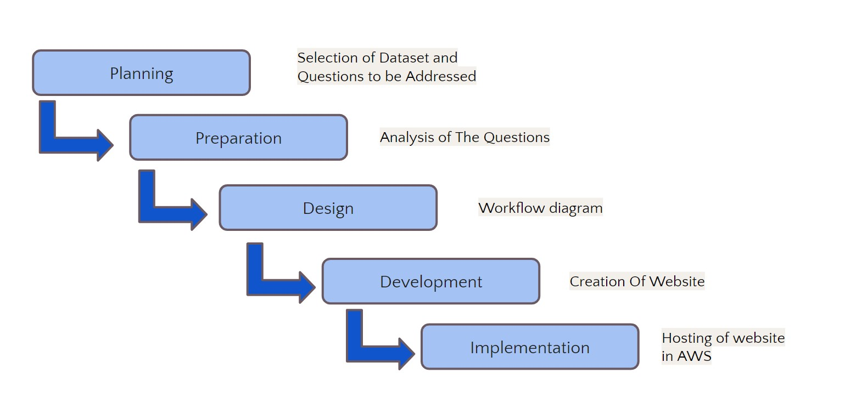

## 4.1 Data Analytics

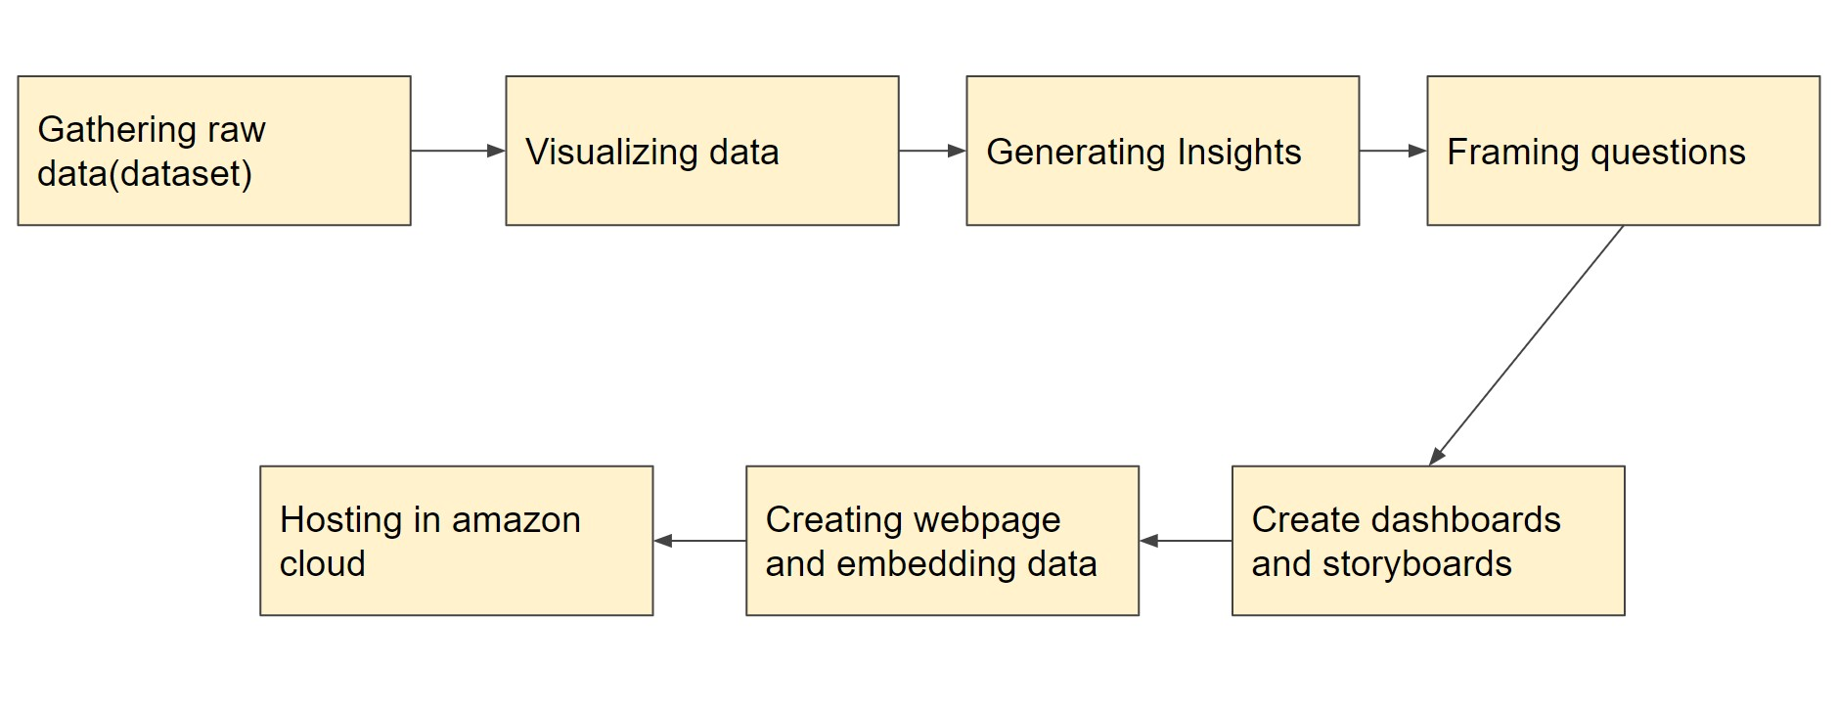

### 4.1.1 Problem Statement

**Problem**

* A country’s happiness is really important for the country’s growth.
* It is really important to know about how we can improve it.

**Solution**

* We have addressed the important questions and done an analysis to give an insight into how the happiness of a country can be improved.

### 4.1.2 Questions To Be Visualized

1. What is the overall situation in the world regarding happiness?
2. Which countries are better positioned in each of the aspects?
3. Finding the reason why happiness rank changed over the years in different regions?
4. In what ways, Generosity and Health play a role in impacting the world happiness score?
5. Does a country's GDP affect the happiness rate?
6. What is the trend followed by India’s happiness score in the past 5 years?
7. Which country had more trust in the government with respect to freedom?
8. An analysis to find which are the factors causing fewer happiness scores in a few regions and prediction on how it would be if each factor is improved.

## 4.2 Web Development

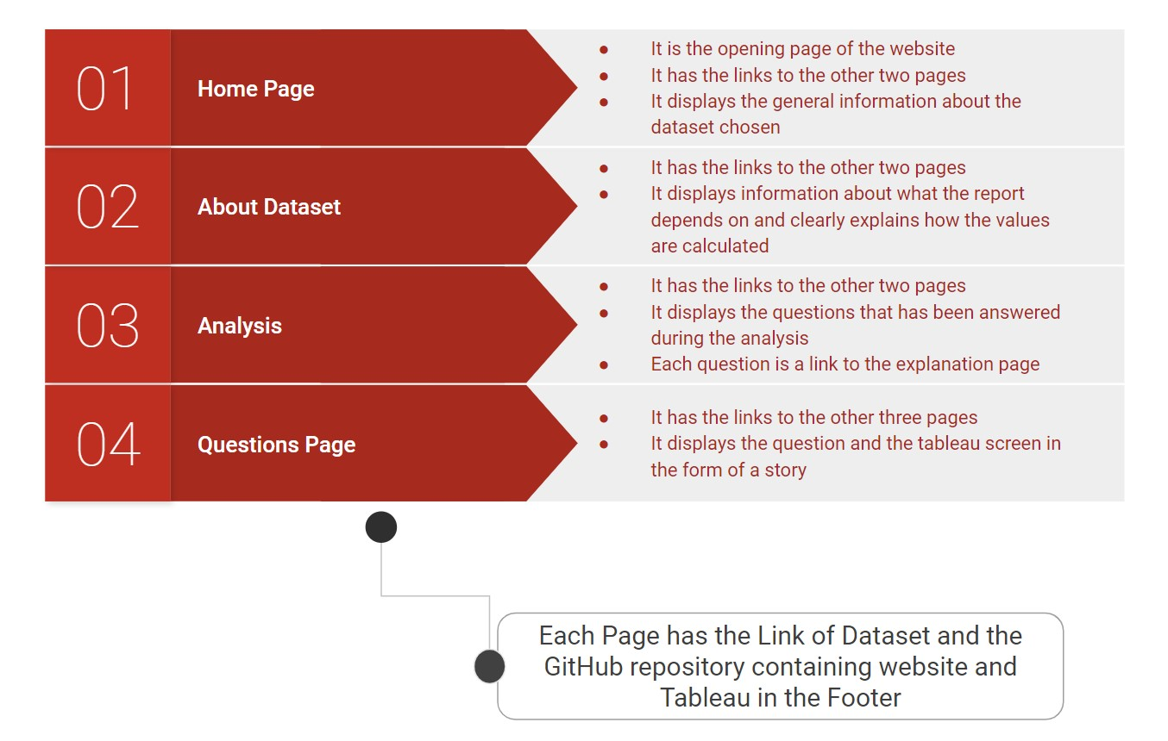

**5. TECHNOLOGIES USED:**

## 5.1 Data Analytics

### 5.1.1 Tableau

Tableau is a visual analytics platform transforming the way we use data to solve problems—empowering people and organizations to make the most of their data.

It is one of the fastest evolving Business Intelligence (BI) and data visualization tools.

It is very fast to deploy, easy to learn and very intuitive to use for a customer.

### 5.1.2 MySQL

MySQL is the world's most popular open-source database. It can cost-effectively help you deliver high performance, scalable database applications.

It is a relational database management system based on the Structured Query Language, which is the popular language for accessing and managing the records in the database.

It is open-source and free software under the GNU license. It is supported by Oracle Company.

### 5.1.3 Jupyter Notebook

Jupyter is a free, open-source, interactive web tool known as a computational notebook, which researchers can use to combine software code, computational output, explanatory text and multimedia resources in a single document.

Can be used for all sorts of data science tasks including data cleaning and transformation, numerical simulation, exploratory data analysis, data visualization, statistical modelling, machine learning, deep learning, and much more.

## 5.2 Web Development

### 5.2.1 Visual Studio Code

Visual Studio Code is a source code editor that can be used with a variety of programming languages, including Java, JavaScript, Go, Node. js, Python and C++. It is based on the Electron framework, which is used to develop Node. js Web applications that run on the Blink layout engine.

Written in: TypeScript, JAvaScript, HTML and CSS.

### 5.2.2 Angular 11

Angular is a TypeScript-based open-source web application framework led by the Angular Team at Google and by a community of individuals and corporations. Angular is a complete rewrite from the same team that built AngularJS

Angular is a platform and framework for

building single-page client applications using HTML and TypeScript. ... Components define views, which are sets of screen elements that Angular can choose among and modify according to your program logic and data.

### 5.2.3 HTML, CSS, Bootstrap, and TypeScript

HTML: HTML stands for HyperText Markup



Language. It is used to design the front-end portion of web pages using a markup language. It acts as a skeleton for a website since it is used to make the structure of a website.

CSS: Cascading Style Sheets fondly referred to as CSS is a simply designed language intended to simplify the process of making web pages presentable. It is used to style our website.

Bootstrap: Bootstrap is a free and open-source front end development framework for the creation of websites and web apps. The Bootstrap framework is built on HTML, CSS, and



JavaScript.

TypeScript: TypeScript is a programming language

developed and maintained by Microsoft. It is a strict syntactical superset of JavaScript and adds optional static typing to the language.

### 5.2.4 GitHub

GitHub is a code hosting platform for version control and collaboration. It lets you and others work together on projects from anywhere.

#### 5.2.5 AWS(Amazon Web Services)

Amazon Web Services (AWS) is a secure cloud services platform, offering computing power, database storage, content delivery and other functionality to help businesses scale and grow.

Deliver static and dynamic files quickly around the world using a Content Delivery Network (CDN).

**6.IMPLEMENTATION:**

## 6.1 Data Visualization-Tableau

We first started with the searching of the dataset for our topic World Happiness Report between the years 2015-19. Then selected the dataset from <https://www.kaggle.com/>[https://www.kaggle.com/mathurinache/world-happiness-report?select=20 15.csv](https://www.kaggle.com/mathurinache/world-happiness-report?select=2015.csv)-The Link to the dataset selected. Then we went on with the cleaning of the dataset like similar countries had different names in a few of the years. So, we changed values like those to their appropriate ones.

The next step was to import the data (tables) to MySQL to create a live connection with Tableau. Importing Data to MySQL was important because if we had any updates it would be easier for changing the data in the dataset.

Then we made a connection between MySQL and Tableau Desktop and then started creating plots, graphs and tables for the questions framed for visualization.

**0.What is the overall situation in the world regarding happiness?**

First, we plotted a graph that shows the regions and the happiness scores of the countries. We analyzed that darker shaded countries are mostly a part of North America and ANZ and Western Europe which implies that they have higher happiness scores in comparison to the other regions.

Next, we plotted a treemap and from that, we got to know that happiness score generally was affected by two major factors, ie., Social Support and Economy(GDP per capita) throughout the world. And Generosity and Trust were the bottom 2 factors accepting the Happiness Score

Then we compared the top 2 factors with happiness scores with respect to regions. From that graph, we came to a conclusion that Economy and GDP per capita equally contributed to the Happiness Score.

So, this is the overall situation of the world in regard to happiness and its score.

**1.Which countries are better positioned in each of these aspects?**

For this analysis, we plotted a bar graph of the Top 10 countries with respect to all the 6 factors on the basis of their Happiness Scores.

Economy(GDP Per Capita): Through this graph, we can view that Qatar has the highest score of 1.7 followed by Luxembourg and Singapore. And we came to a conclusion that, due to Qatar's high GDP, it is one of the richest countries and also ranks a high position in the world happiness report.

Freedom: Through this graph, we can view that Uzbekistan has the highest score but has one of the least happiness scores and ranks. On the other hand, Norway, the 2nd highest country in regard to freedom ranks the highest position in the world happiness report. This meaning Freedom is not one of the main factors for happiness.

Generosity: Through this graph, we can view that Myanmar has the highest score of 0.72. Though the score is less when compared to the other factors, the score of the 2nd highest country is 0.5 which is very less. So on average Myanmar has the highest score in terms of generosity according to people's opinion.

Health(Life Expectancy): Through this graph, we can see that Singapore and Hong Kong have the highest scores amongst the other countries. This implies that these countries have very good health infrastructure and higher life expectancy.

Social Support: Through this graph, we can view that Iceland has the highest score of social support in terms of peoples opinion which implies that people in Iceland have enhanced quality of life in adverse life situations due to the support from their family and friends.

Trust(Government Corruption): Through this graph, we can view that Rwanda and Singapore have the highest score. Another important point to notice is that though these countries have the highest position, the score is less than 0.5 which is very less when compared to all the other factors. So we can understand that on average the trust in government is low throughout the world due to activities like corruption.

**2.Finding the reason why happiness rank changed over the years in different regions?**

In this analysis, we looked upon the countries that we’re improving and deteriorating over the years.

The first table displays the list of countries that are improving and deteriorating throughout all the five years (2015-2019) on the basis of the happiness rank. Then we plotted a bubble chart for both the variations and we observed that social support and economic GDP makes some changes in the improving and deteriorating countries compared to other aspects. The improving and deteriorating were grouped using the create group function available in Tableau.

Then we plotted a dual-axis line graph to compare on the basis of the 3 main factors: Social Support, Economy (GDP per capita) and Generosity.

**3.In what ways, Generosity and Health play a role in impacting the world happiness score?**

This Analysis was made to find whether there is a relationship found between Generosity and Health. Generally, studies say that people who are generous are said to be happier and eventually have a higher life expectancy. So we checked whether that was true.

First, we plotted a histogram for Health(Life Expectancy) and the Count of Countries given the particular score. We were able to clearly see that most of the countries have given their score between 0.50 to 0.90, we can say that the Health(Life Expectancy)score on an average is high in most of the countries as per people's opinion.

Then we did the same with respect to Generosity. In this graph we were able to see that most of the countries have given their score between 0.05 to 0.30, we can say that the generosity score on an average is low in most of the countries as per people's opinion.

Now to compare both the factors side by side we plotted a box-plot. From these boxplots, we can see that the score given by people for Generosity is really less than Health. North America and ANZ are at the top in both the factors, whereas Sub-Saharan Africa is in the least in Health(Life Expectancy). Central and East Europe is the bottom-most region in terms of Generosity. And in a few years like 2015 and 2019 Sub-Saharan Africa is outside the boxplot meaning they did not follow the trend and are called outliers. One more important thing to notice is that The score of health is much higher than generosity.

So now to check if a correlation exists we plotted a linear regression trend line over a scatter plot. Through this graph, we can understand that there is some kind of correlation found between health and generosity as most of the scatter points lie near the trendline. The trendline shows an inclination which implies that they have a positive correlation. And, since the inclination angle is less, it follows a weak positive correlation trend. This means that there is a correlation between both of the factors.

So, we can come to a conclusion that Generosity and Health are co-related with respect to happiness score.

**4.Does a country's GDP affect the happiness rate?**

In this analysis, we checked whether the Economy of the country affects the happiness score/rank of the same.

First, we plotted a graph that shows a comparison between Happiness score and Economy(GDP per capita). A linear trendline has been plotted on the scatter plot, in which the line shows a large inclination and points are closer to the line. This shows that there is a positive correlation between both factors.

Then we plotted a treemap with respect to the GDP and Happiness Score in regard to each region. From the treemap, we can analyze that North America and ANZ and Western Europe have the highest score. On the other hand, South Asia and Sub-Saharan Africa have the least score in both factors. So then we created a group on the above basis.

The scatter plot splits all the countries into 3 categories namely top, bottom and middle with respect to region. If we see the countries in the top group we can see that there is a linear trend line that has a large inclination towards the top showing a strong positive correlation, meaning that the economy has played a major role towards the happiness score in the list of top countries. On the other hand, the countries in the least group also show an inclination towards the top but the angle is too low which implies a weak positive correlation meaning a low economy is not the only reason for their least happiness score. And the mid-range countries have a mediocre inclination towards the top. So, we can understand from the graph that the Economy(GDP per capita) is one of the main reasons for the happiness score but the impact is different for each region.

In the next map, we can visualize that the top countries are following the same pattern in all the years, by seeing their colour codes. On the other hand, the bottom countries are continuously varying. Hence we can conclude that the countries at the top are more stable than the ones at the bottom.

**5.What is the trend followed by India’s happiness score in the past 5 years?**

As we live in India we wanted to analyze India’s situation with regard to happiness

First, we plotted 2 line graphs, one with respect to happiness rand and the other with respect to the happiness score of India. From the first graph, we were able to see that the happiness rank and score of India has been decreasing every year, for the past 5 years. And in the second graph, we can see that the rank is given based on which position India is present in the world regarding happiness, whereas the score would give a much more clear picture regarding the changes that would have happened in India throughout the years.

In the next graph, we can see the factors that would have affected India to have such a low happiness score. The graph clearly shows Economy and Social Support were the 2 main factors contributing to India’s score.

Then we compared all the factors throughout all the years.

Trust(Government Corruption): This graph shows the change in

Trust(government corruption) yearwise. Trust has continuously increased from 2015 to 2018 and had a sudden downfall in the year 2019. We can see that in the year 2019, one of the main reasons for the decrease in happiness score would be the people's trust towards the government. Studies say that the Central Government was accused of destroying democratic institutions and processes after the election was conducted.

Freedom: This graph shows the change in Freedom yearwise. Freedom has continuously increased from 2015 to 2018 and had a sudden downfall in the year 2019. We can see that in the year 2019, one of the main reasons for the decrease in happiness score would be the People's opinion on Freedom.

Social Support: This graph shows the change in Social Support yearwise. Social Support score has decreased in the year 2016 and has had an increase for the next 3 years. We can see that in the year 2016, one of the main reasons for the decrease in happiness score would be the Social Support score.

Generosity: This graph shows the change in Generosity yearwise. Generosity score has continuously decreased till the year 2018 and had an increase in the year 2019. We can see that in the first 4 years, one of the main reasons for the decrease in happiness score would be the Generosity score.

Health(Life Expectancy): This graph shows the change in Health(Life Expectancy) yearwise. Health has continuously improved from 2015 to 2017 and had a sudden downfall in the year 2018 and again raised in the year 2019. We can see that in the year 2016, one of the main reasons for the decrease in happiness score would be due to Health. The lower level of Health can be attributed to the low level of public investments in preventive health facilities such as sanitation and waste management, as well as in medical care facilities such as primary health centres and health professionals.

Economy(GDP per Capita): This graph shows the change in

Economy(GDP per Capita) yearwise. The GDP has continuously increased from 2015 to 2017 and had a sudden downfall in the year 2018 and again raised in the year 2019. We can see that in the year 2018, one of the main reasons for the decrease in happiness score would be the GDP value. The lower GDP growth figures are attributed to weak domestic consumption so, the Indian economy reported a continuous decline in GDP growth rate over the year 2018.

**6.Which country had more trust in the government with respect to freedom?**

This analysis was visualized to know which country has more trust in government with respect to freedom.

First, we plotted a histogram for Trust and the Count of Countries given the particular score. We were able to clearly see that most of the countries have given their score between 0.02 to 0.14, we can say that the Trust(Government Corruption) score on average is low in most of the countries as per people's opinion. And we did the same even for freedom where we can view that most of the countries have given their score between 0.30 to 0.60, we can say that the Freedom score on an average is high in most of the countries as per people's opinion.

Then we plotted dual axes between line and bar graph. From which we can conclude that the factors didn’t have any correlation with each other. Also, according to people's opinion, the sense of Freedom is higher when compared to the trust towards the government. Another point to note is Trust towards the government has negligible change, whereas Freedom is varying highly. And the region of North America and ANZ has the highest score in both the factors, hence has the highest happiness score. There is a big gap between the factors for all the regions.

And then found that Denmark has the highest trust towards the government.

**7.An analysis to find which are the factors causing fewer happiness scores in a few regions and prediction on how it would be if each factor is improved.**

Here for this analysis, we are finding the factors that are causing the lesser happiness score in a few regions i.e., bottom-most countries.

So, first, we plotted a bar graph showing the happiness scores of the bottom-most countries which we are going to study.

From the pie chart, we were able to analyze that these countries are supposed to focus more on their Freedom, Trust and Generosity to go to better positions on the world scale. Even though the Economy and Health are higher compared to other factors, it still would need concentration since it is lower when compared to other countries.

## 6.2 Data Analysis-Python

A prediction was made in python. We created a country called Custom Land meaning you can input your values for all the above factors and get to know what the happiness score might be.

## 6.3 Website Development

We created a static angular website with a few web pages in it and all the Storyboards of the visualizations we made are embedded in it.

**7.OUTPUT:**

## 7.1 Tableau

0.What is the overall situation in the world regarding happiness?

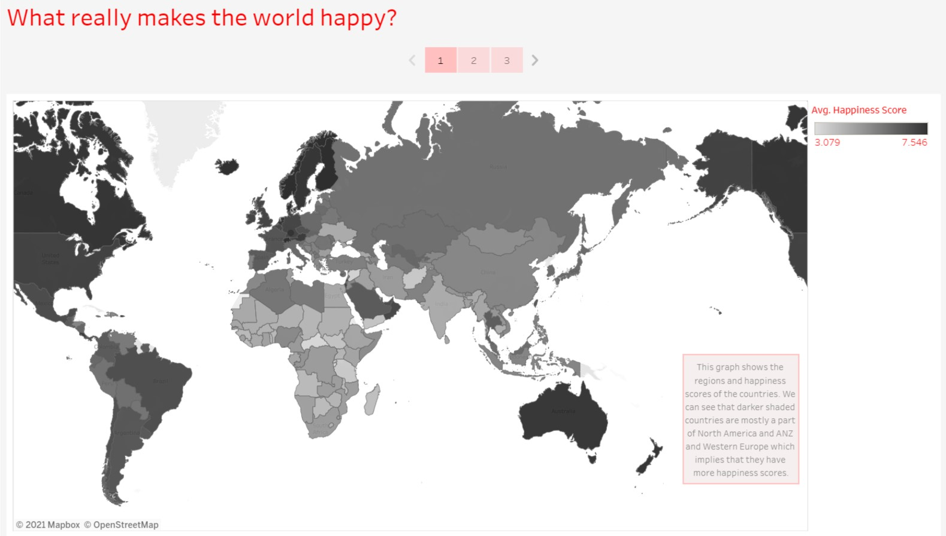

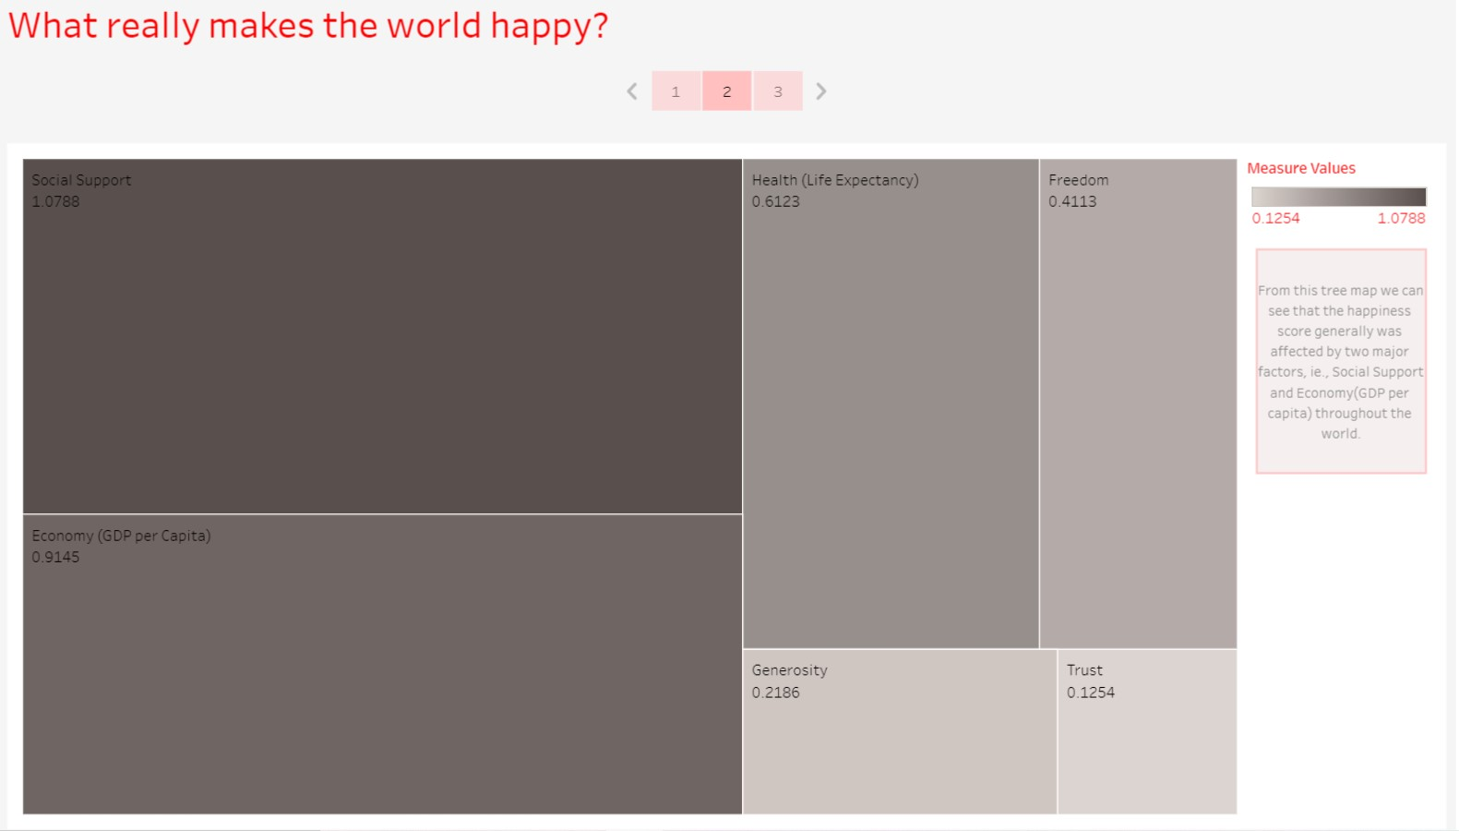

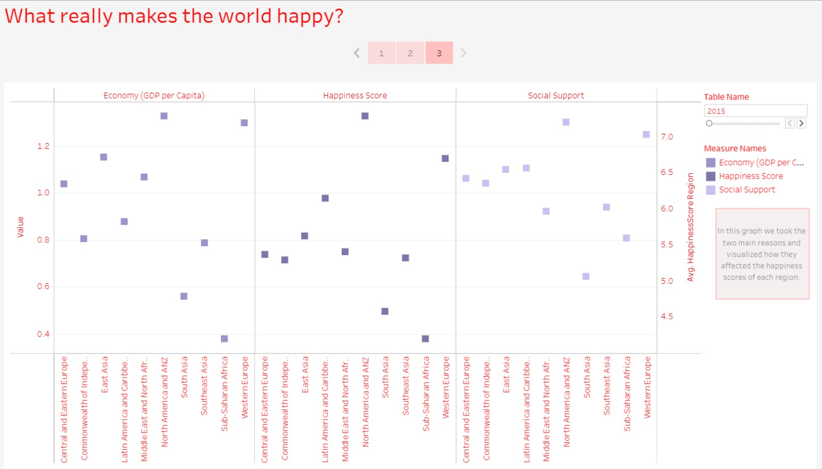

1.Which countries are better positioned in each of the aspects?

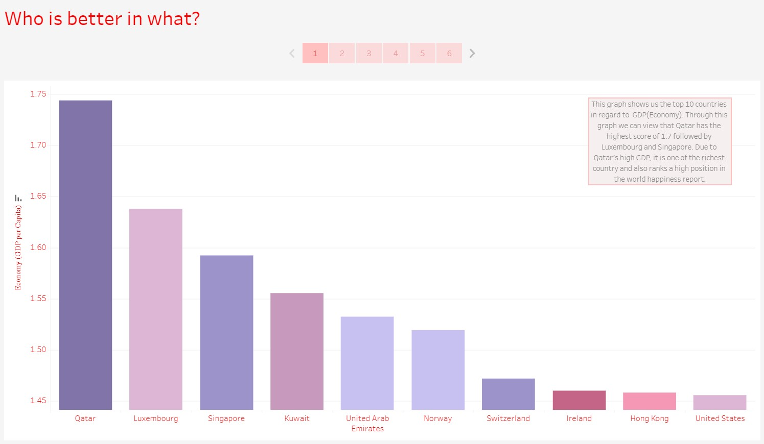

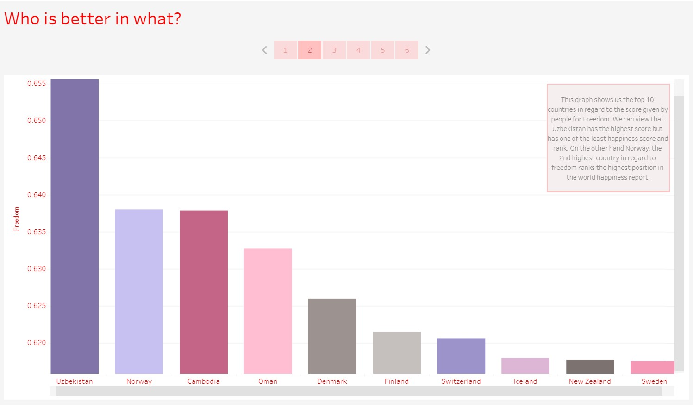

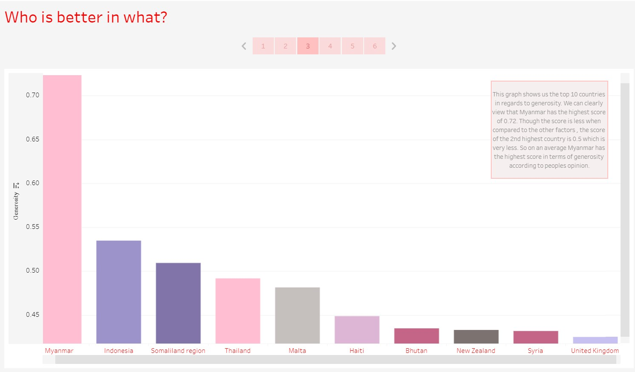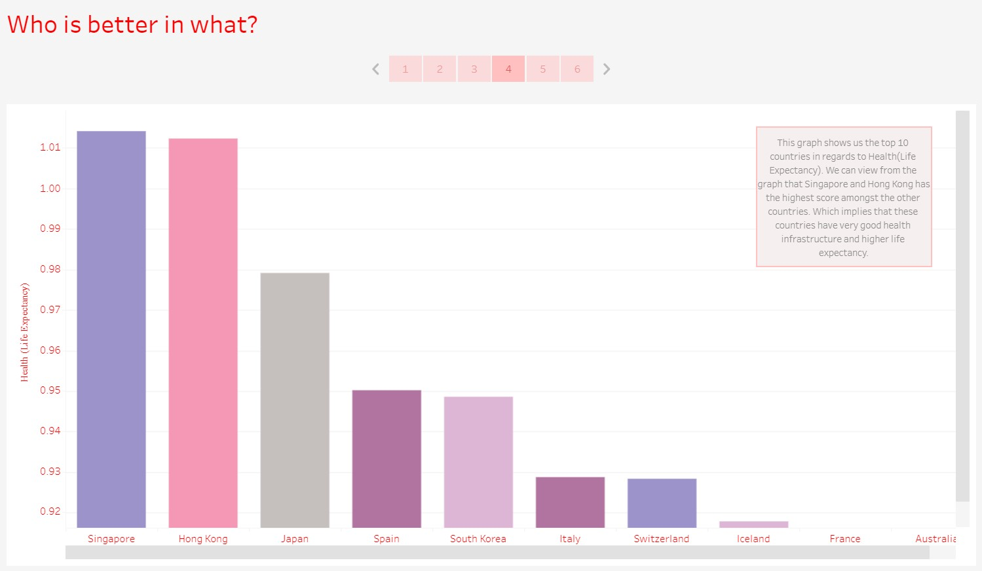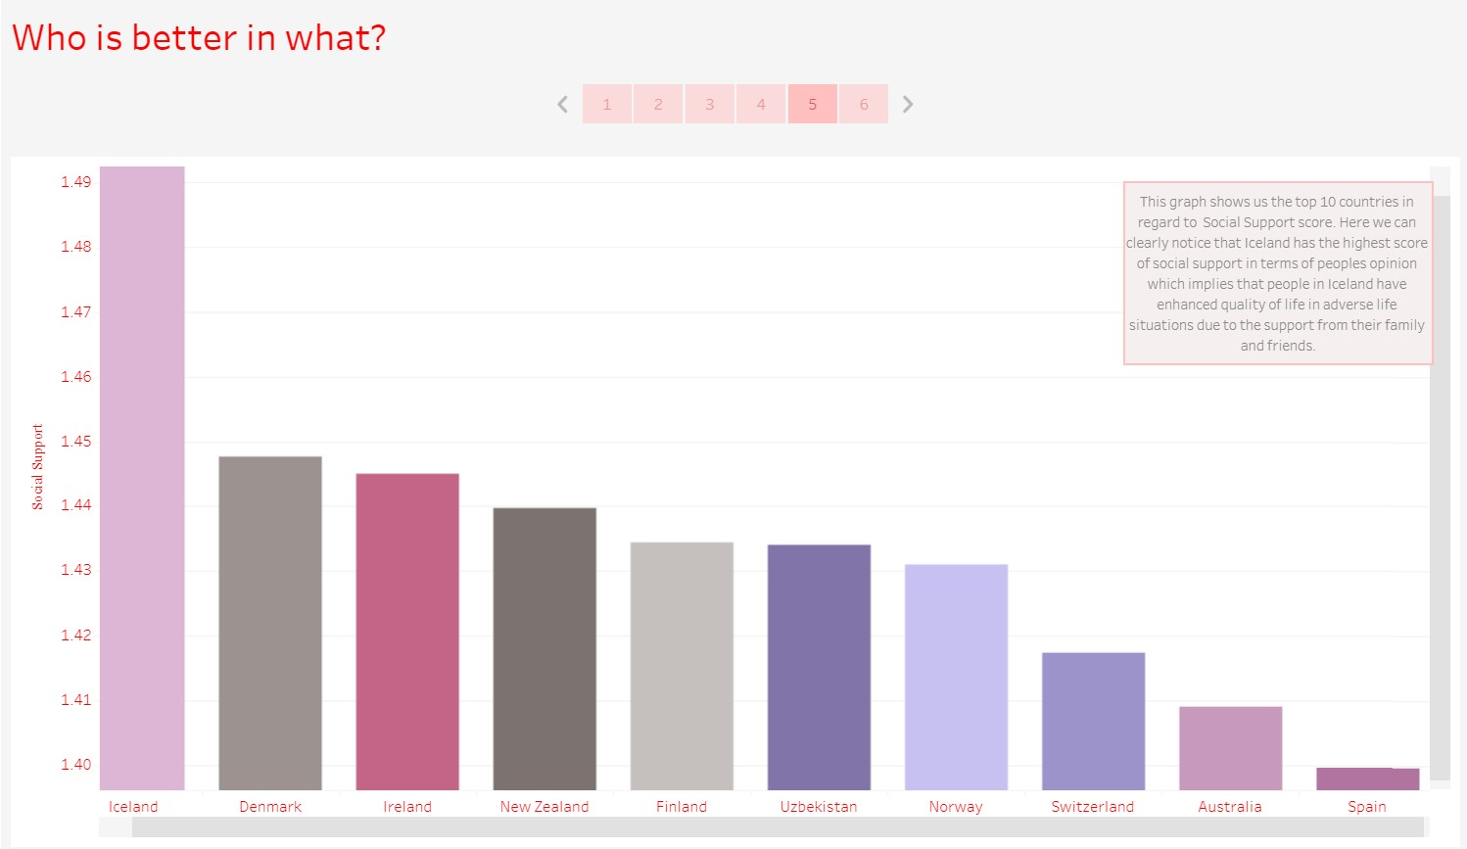

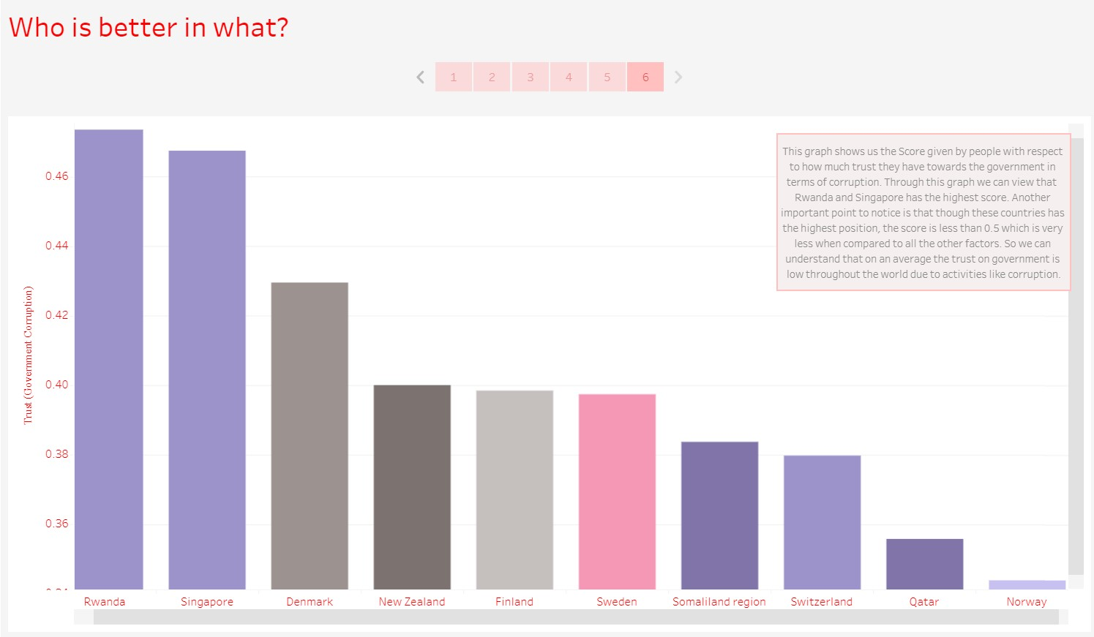

2.Finding the reason why happiness rank changed over the years in different regions?

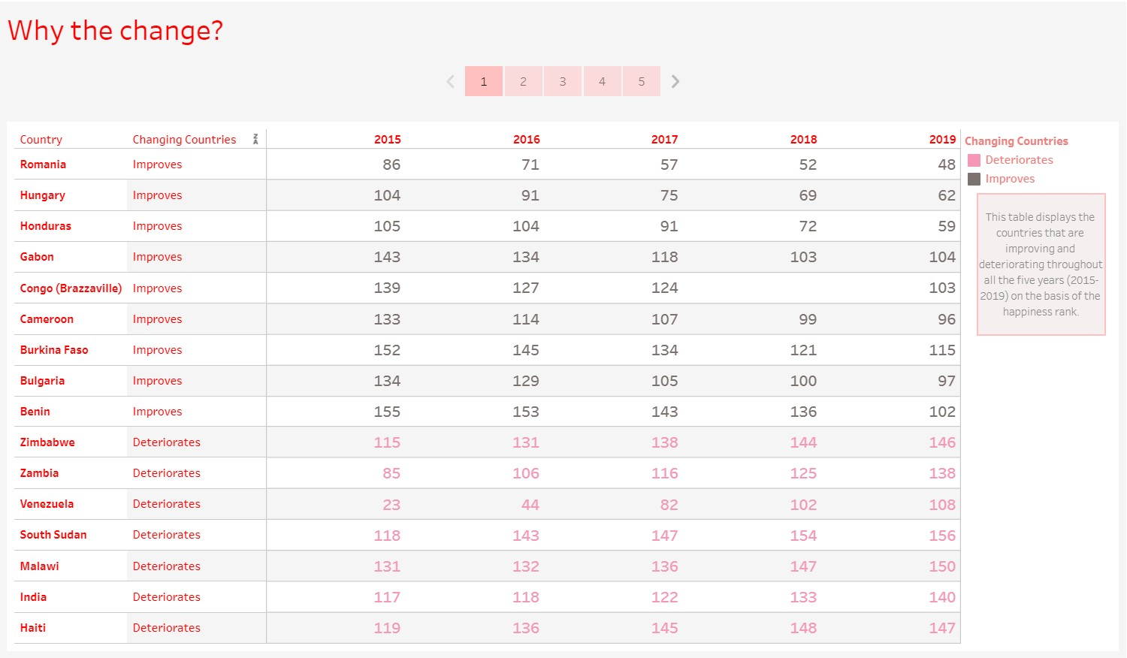

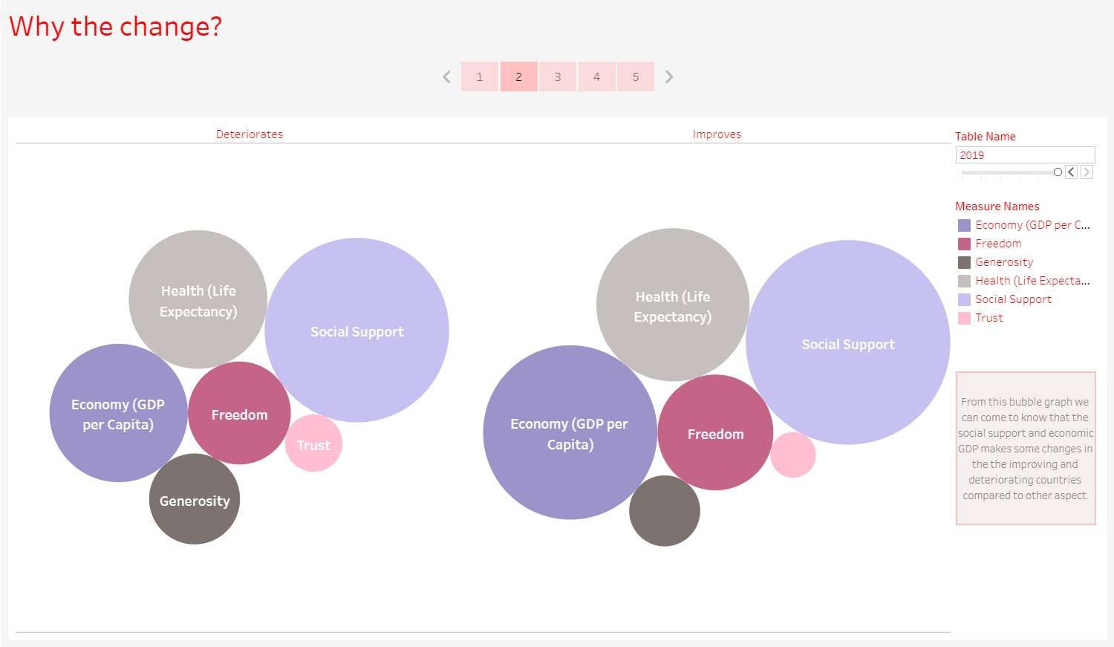

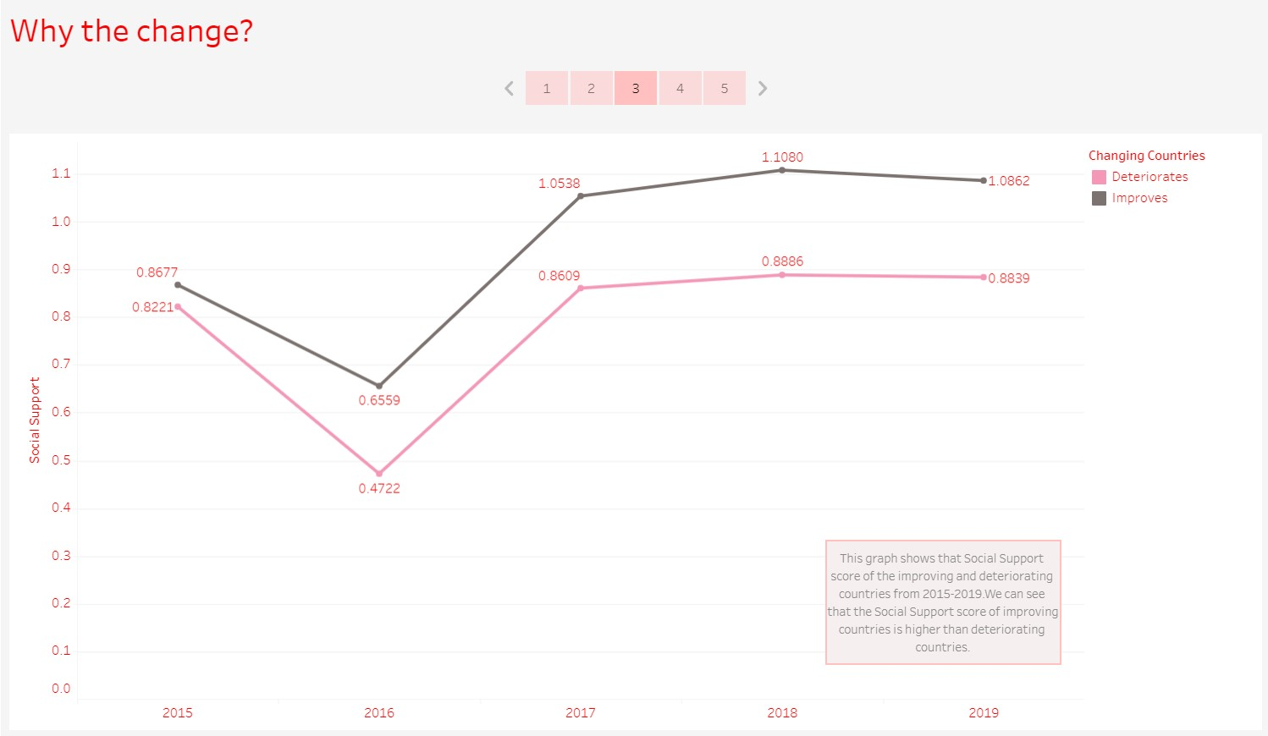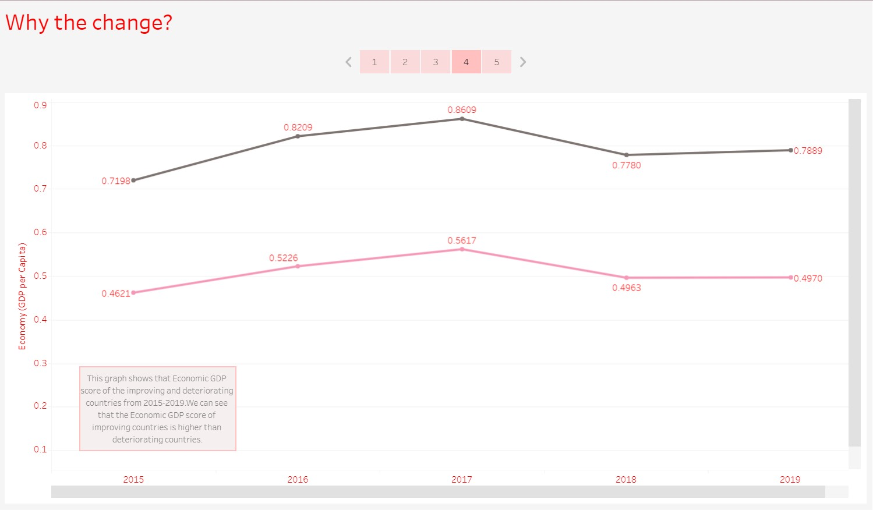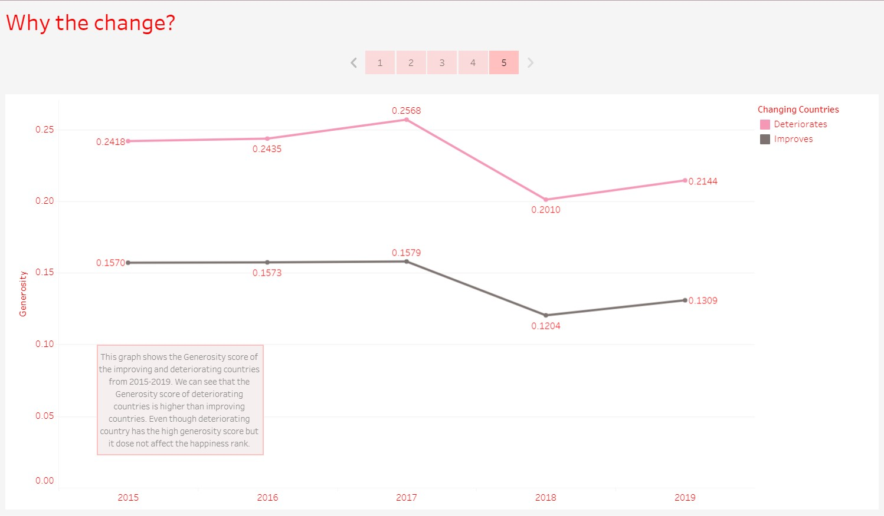

3.In what ways, Generosity and Health play a role in impacting the world happiness score?

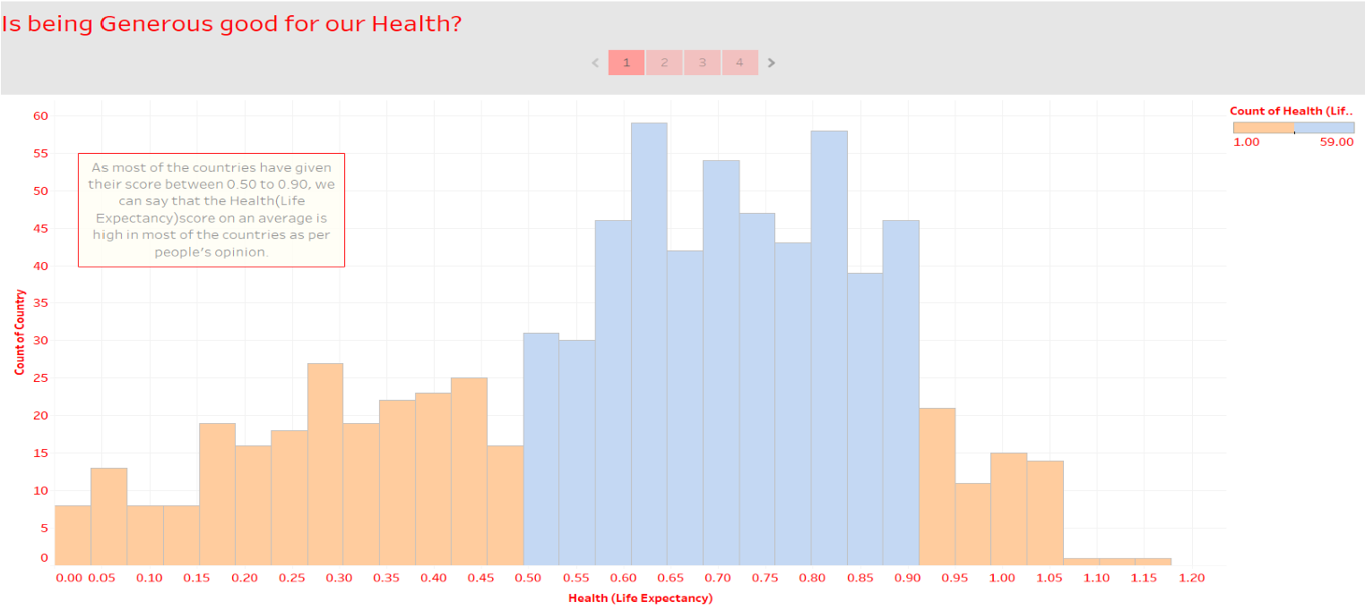

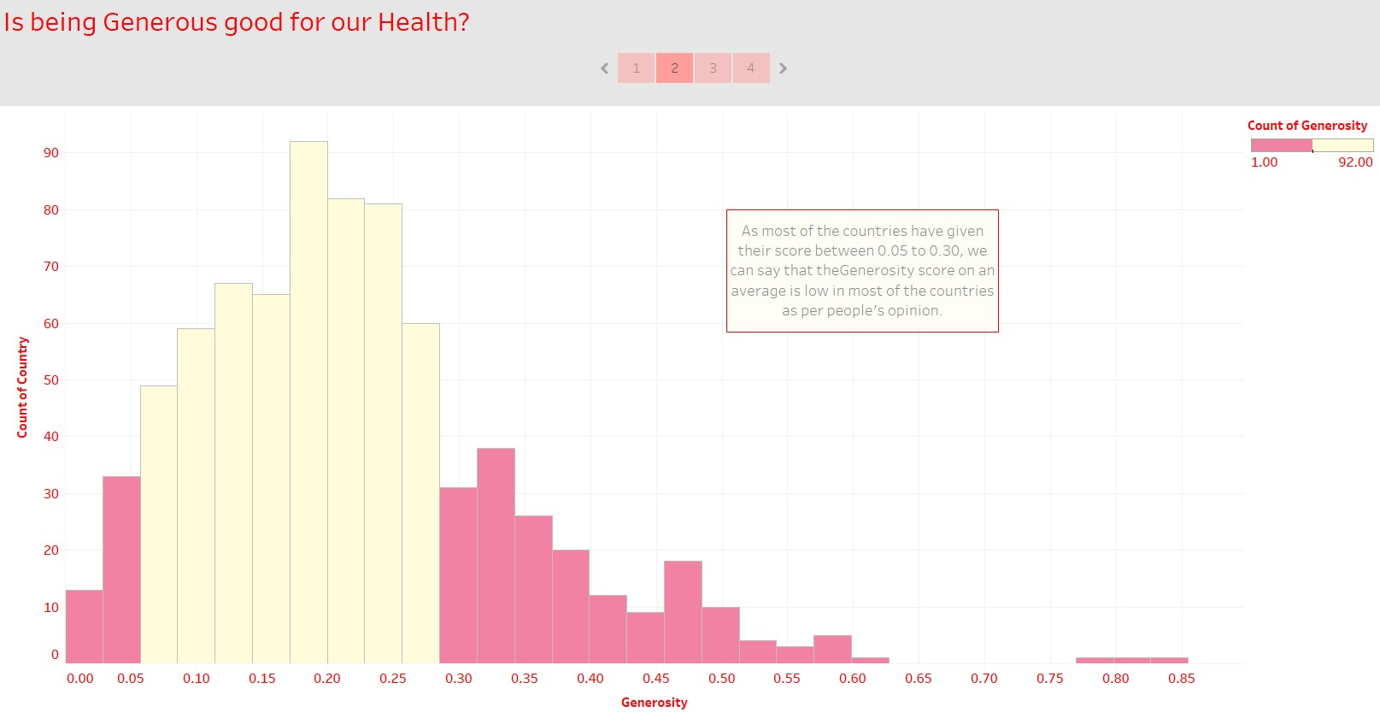

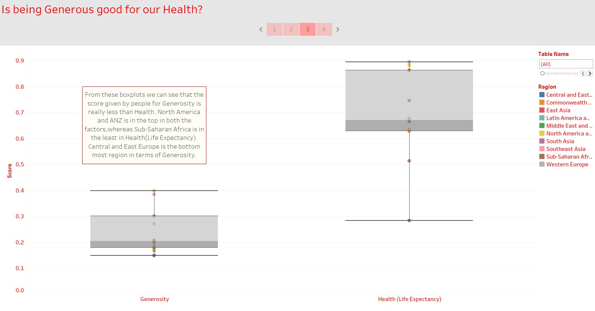

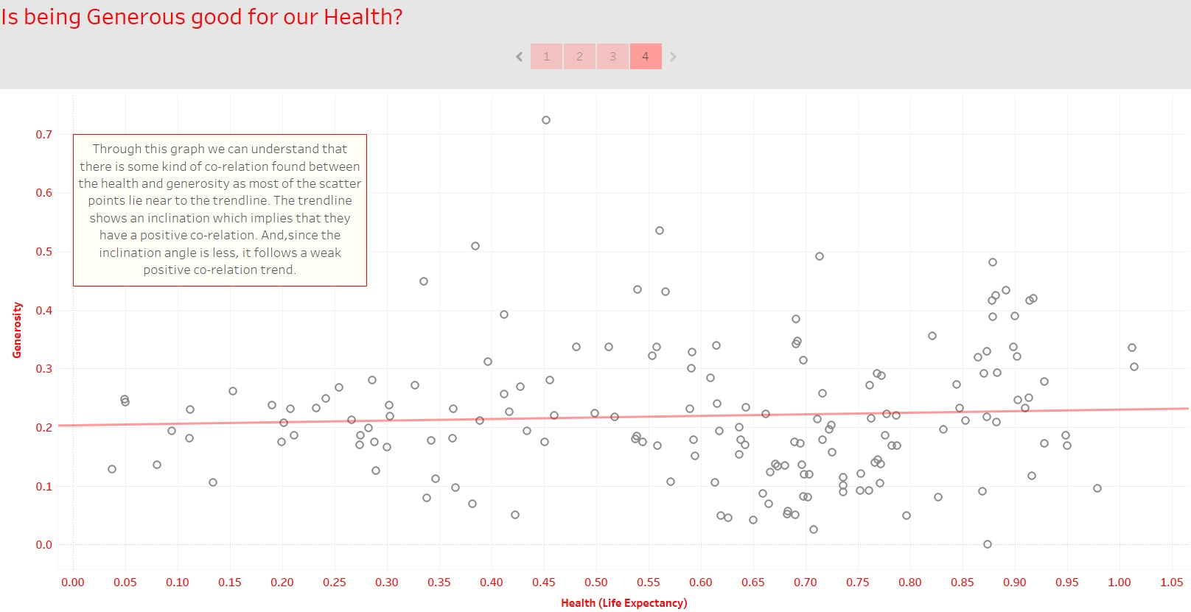

4.Does a country's GDP affect the happiness rate?

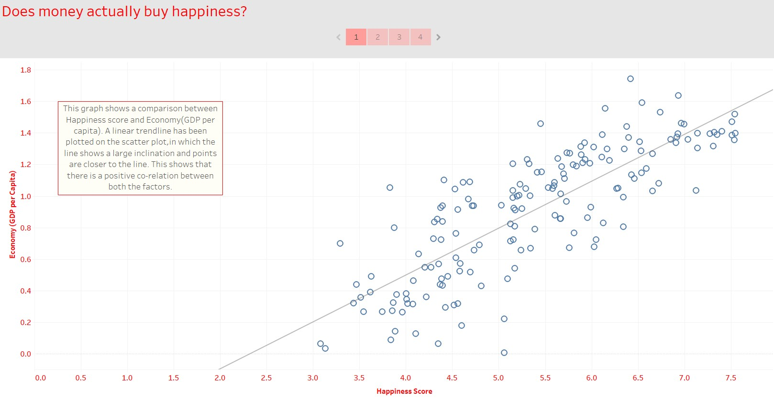

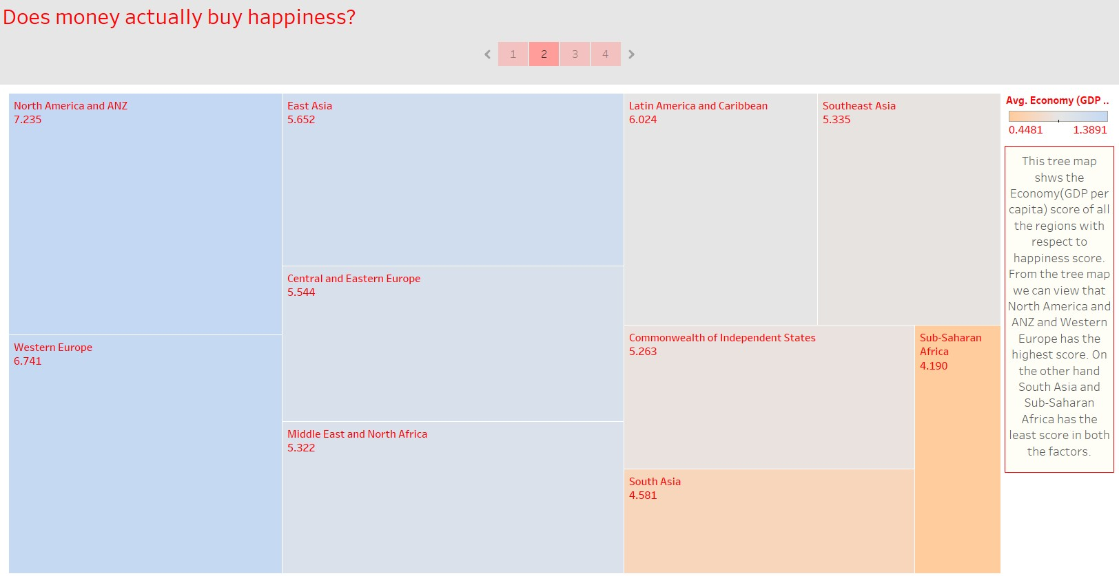

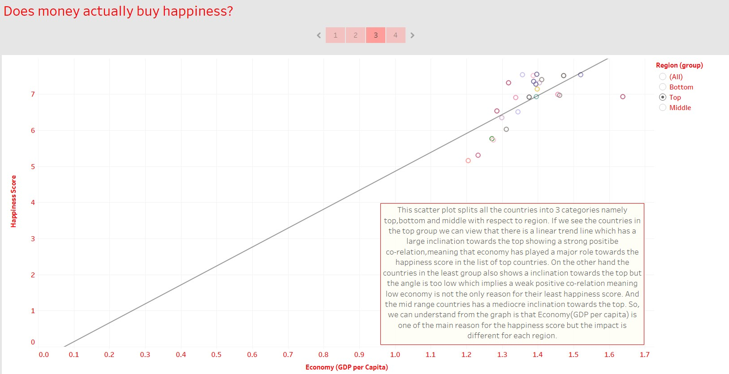

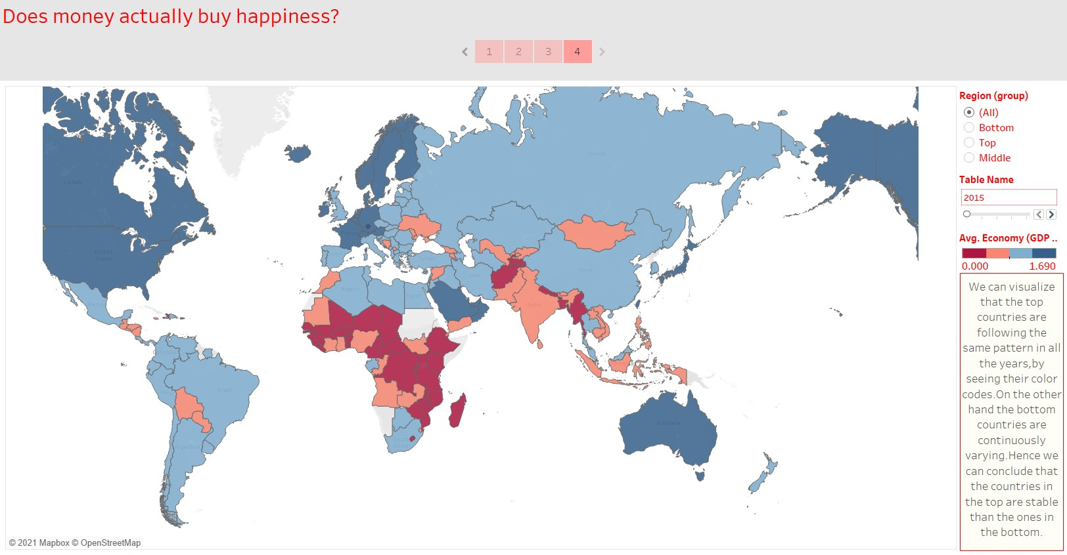

5.What is the trend followed by India’s happiness score in the past 5 years?

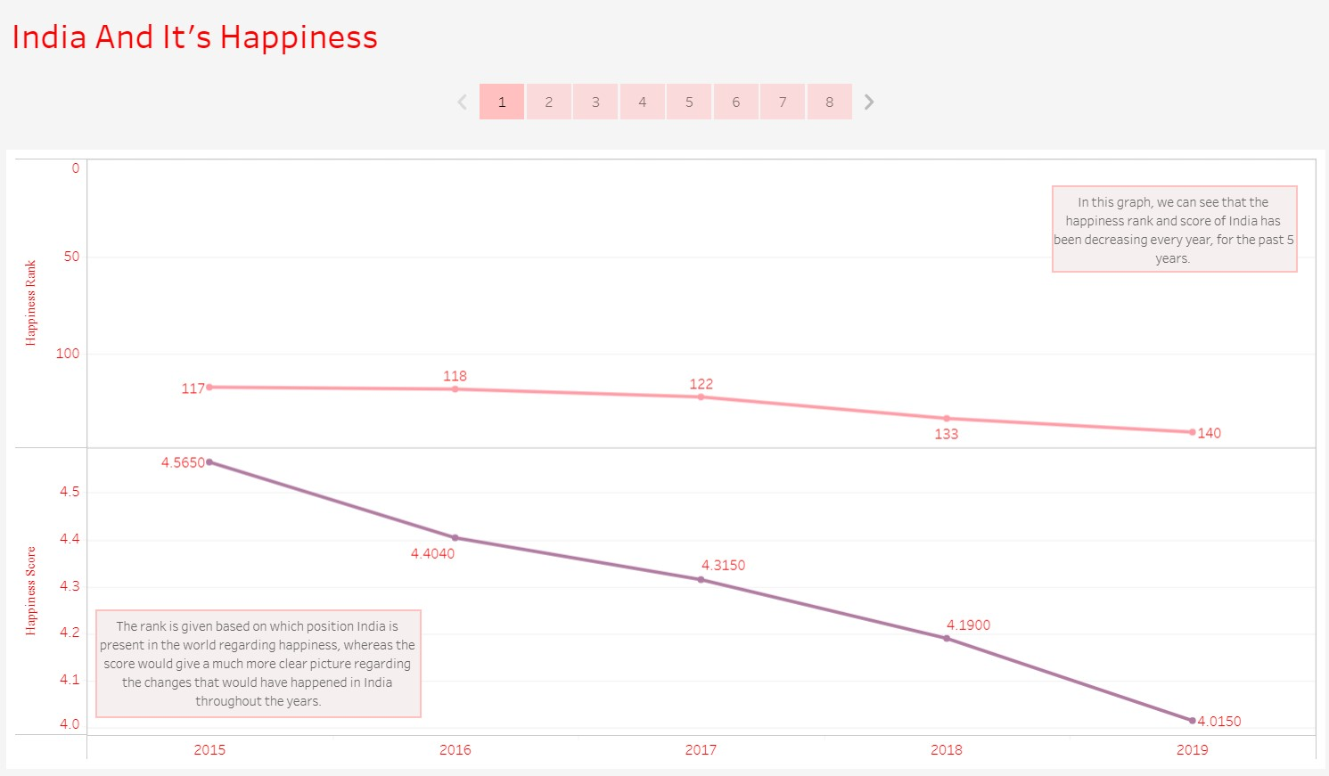

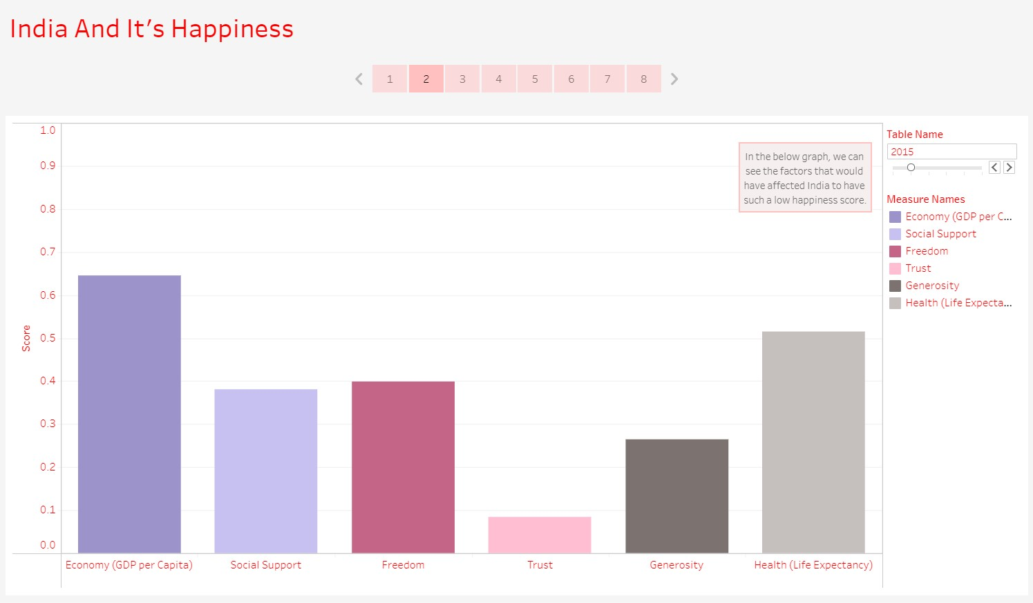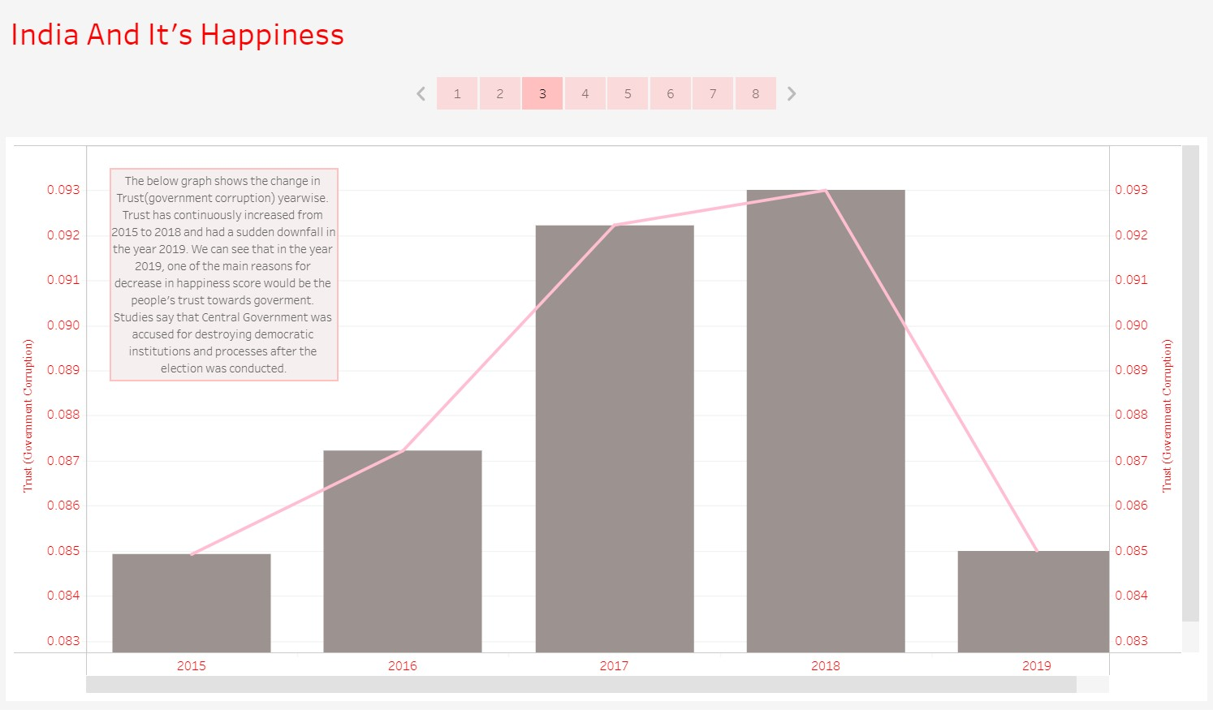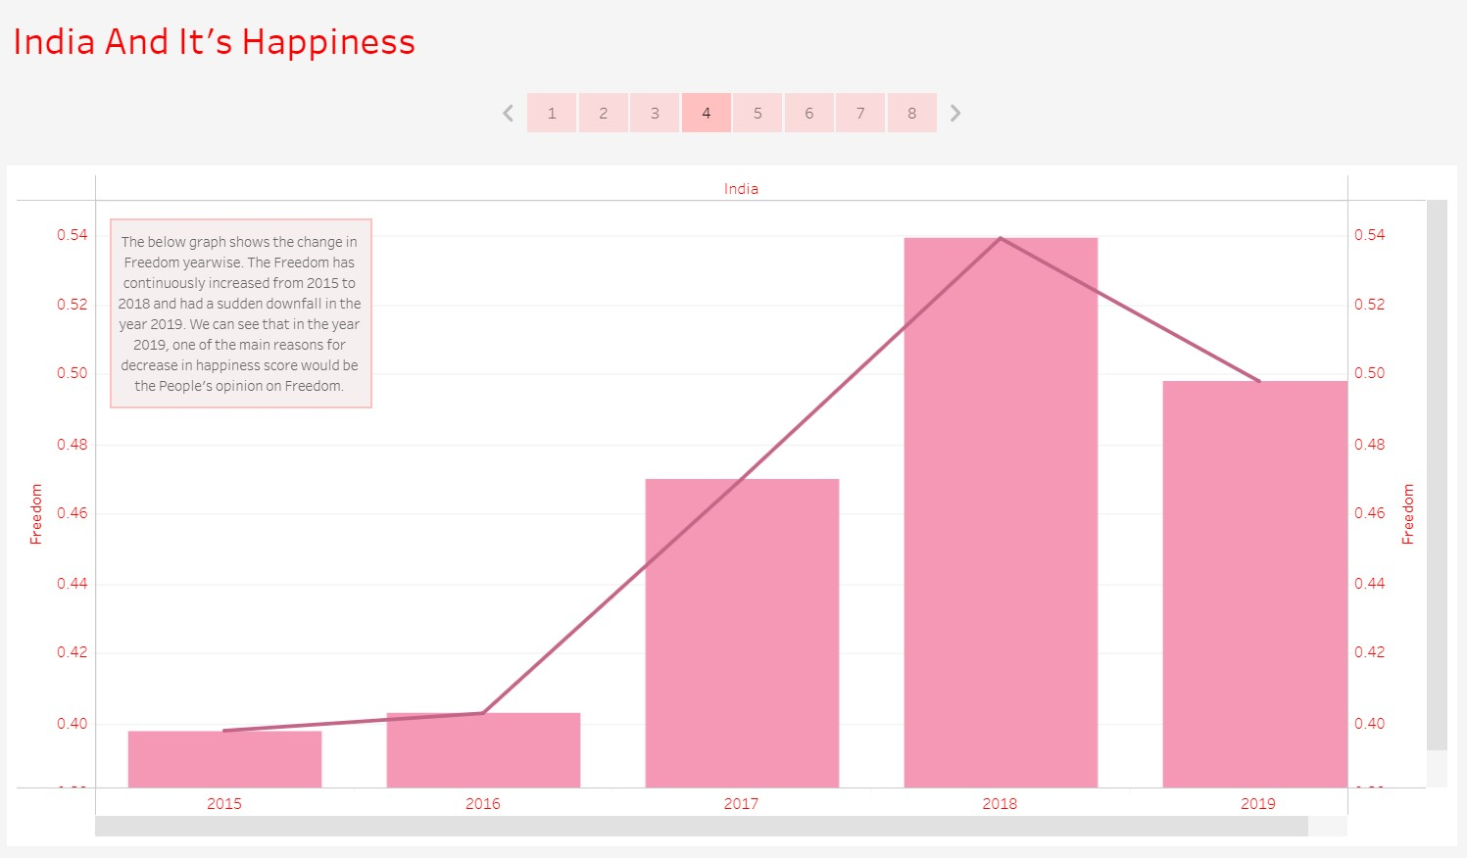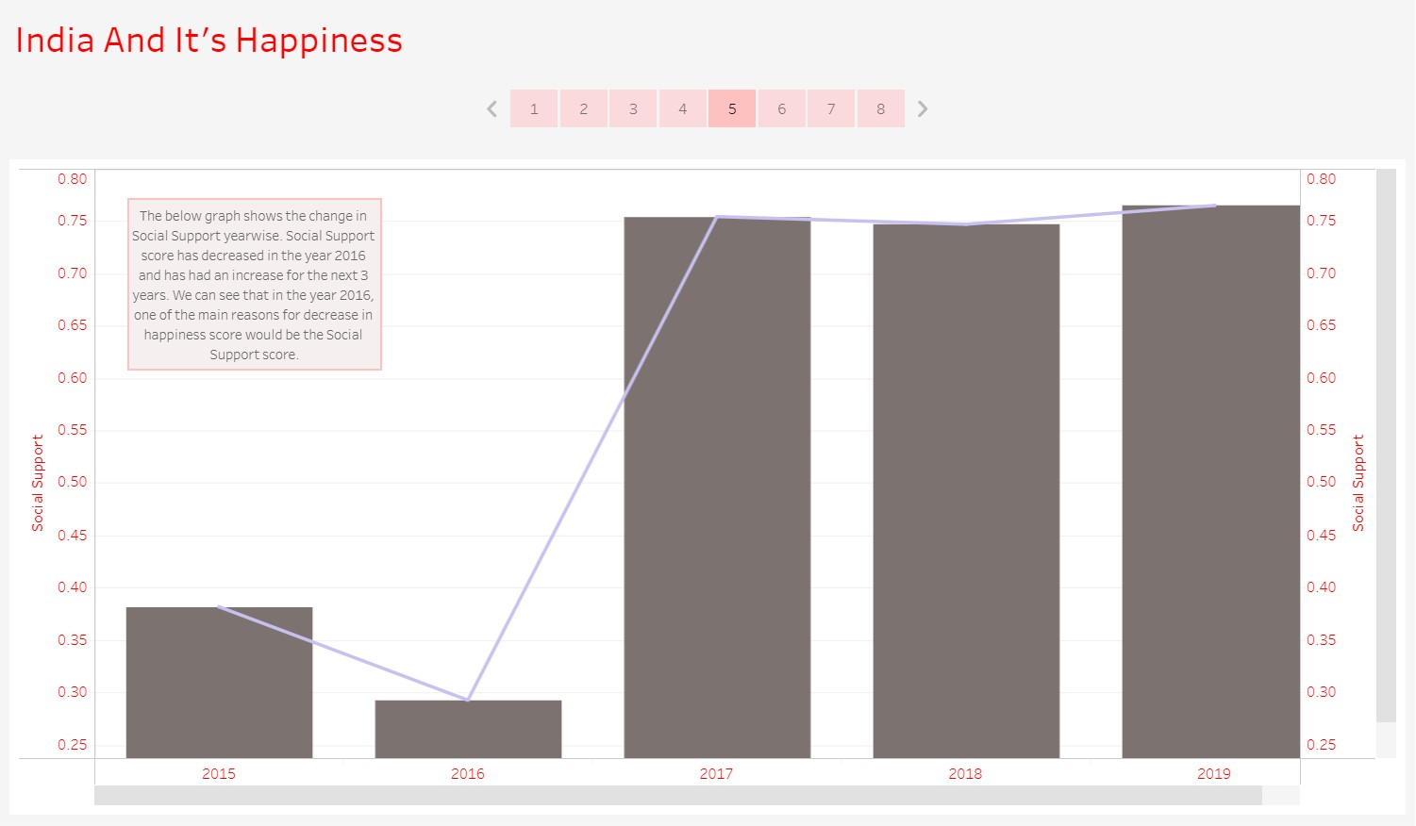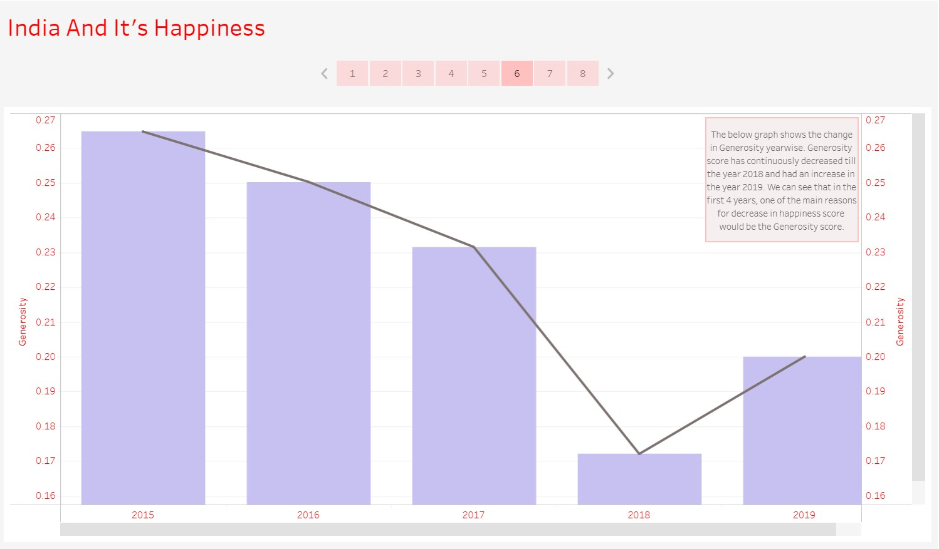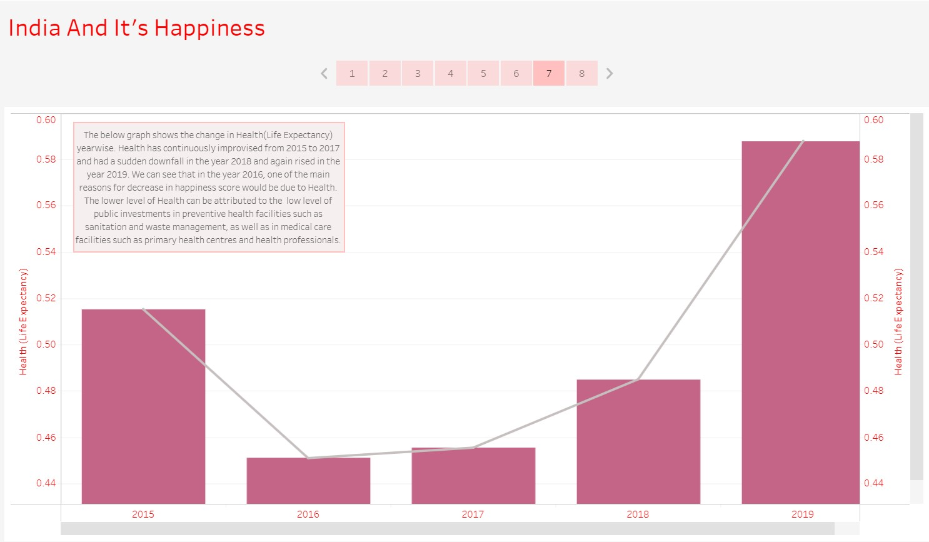

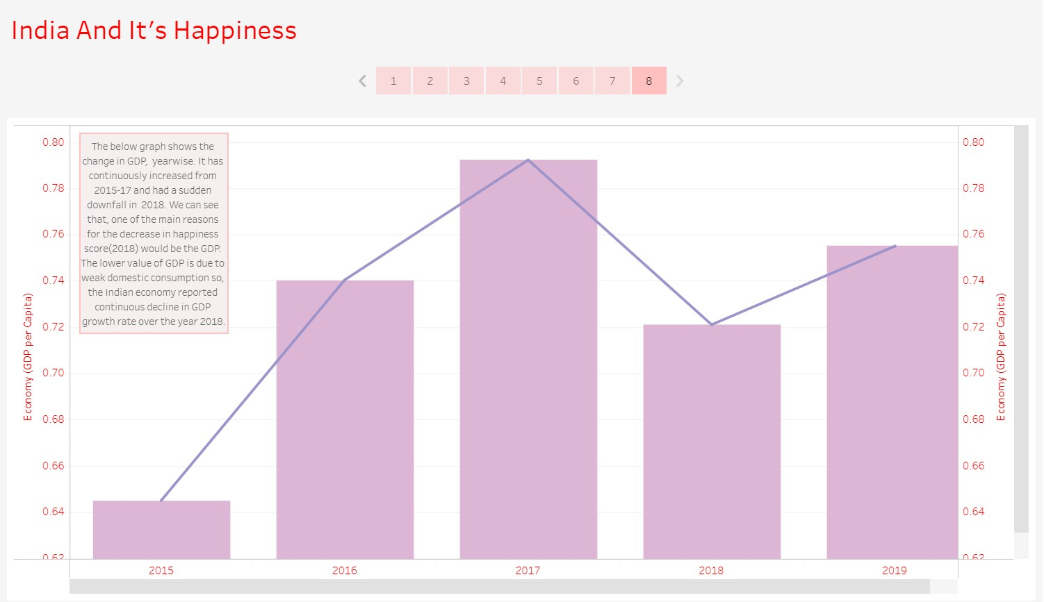

6.Which country had more trust in the government with respect to freedom?

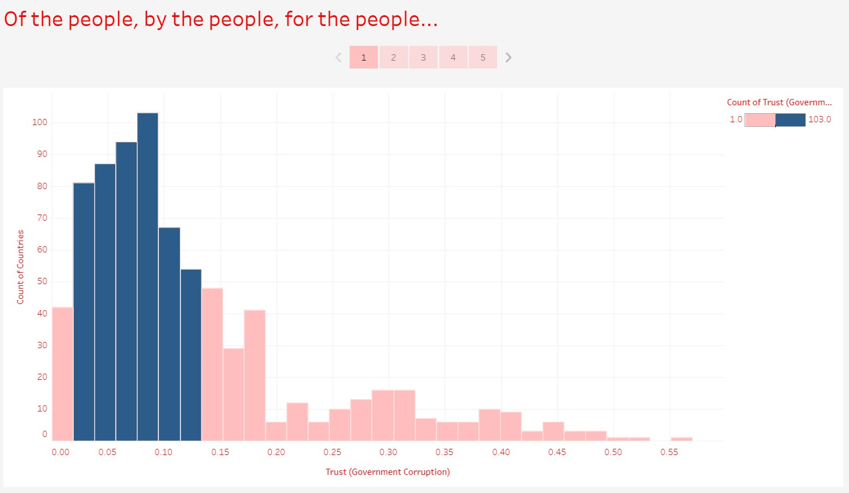

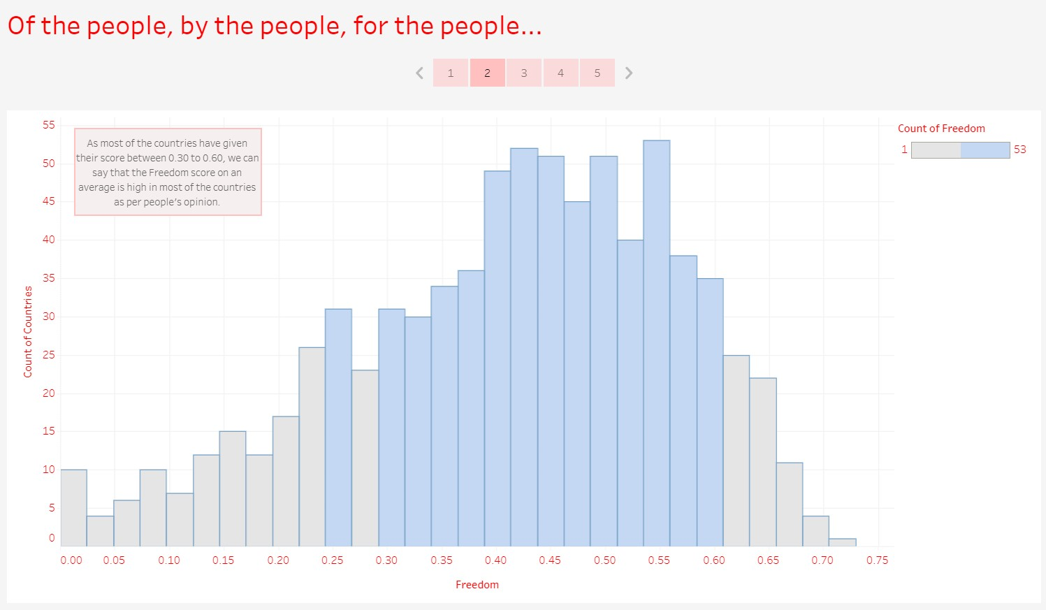

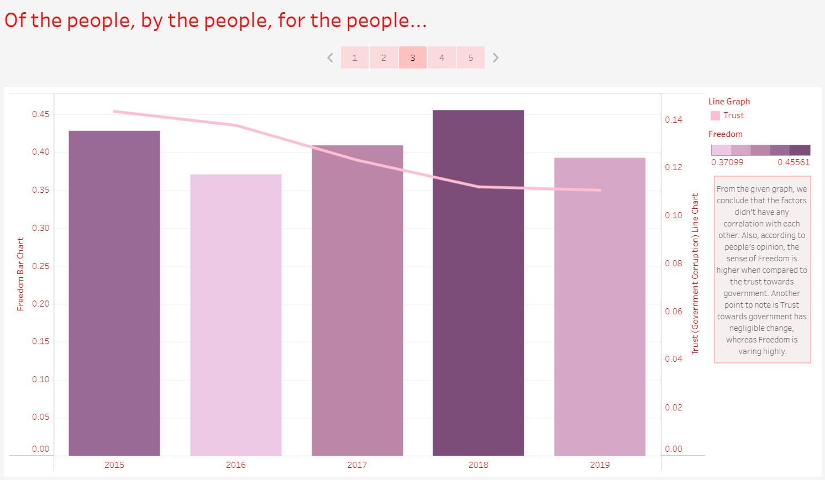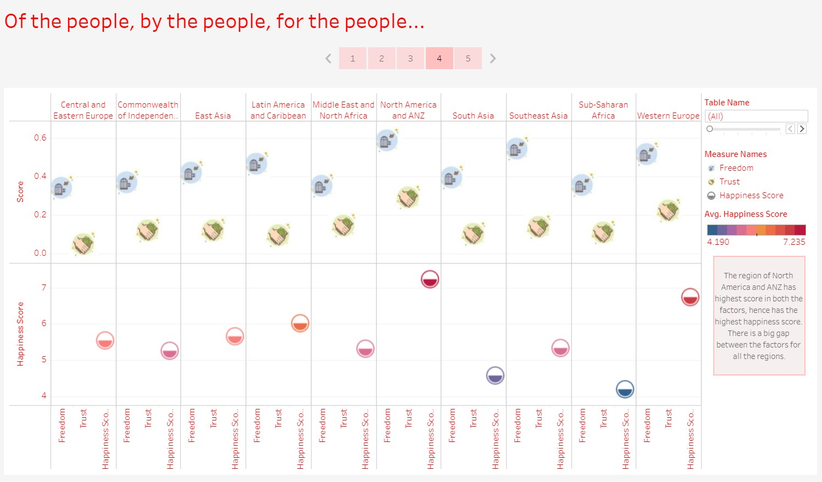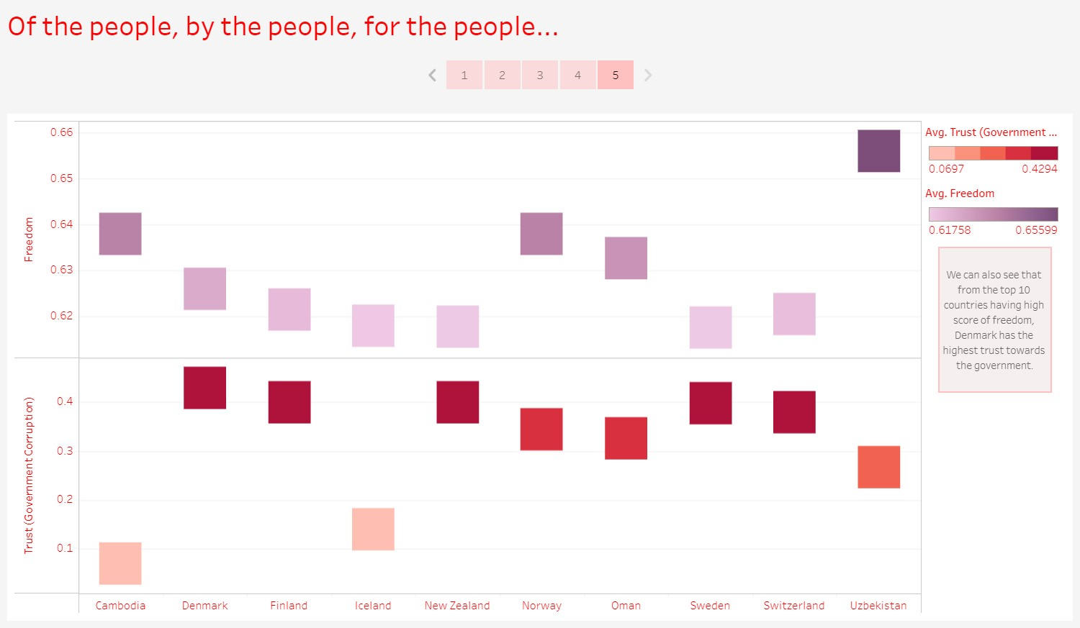

7.An analysis to find which are the factors causing fewer happiness scores in a few regions and prediction on how it would be if each factor is improved.

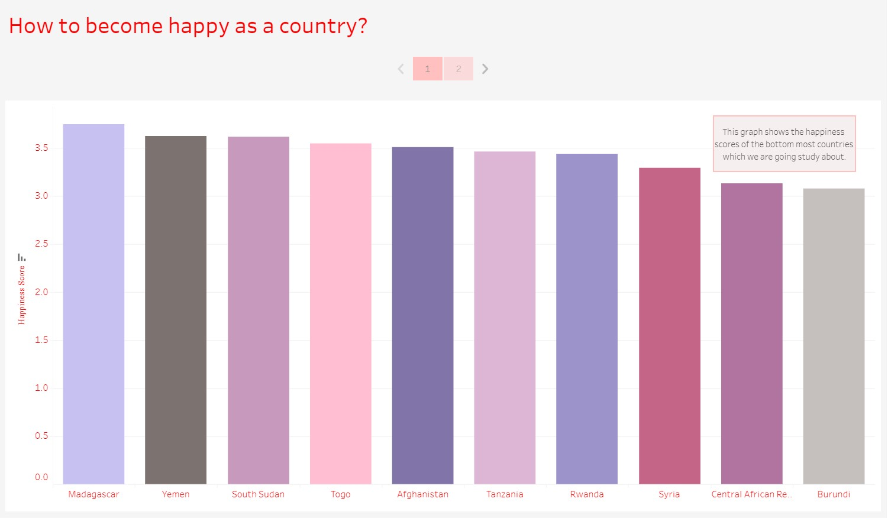

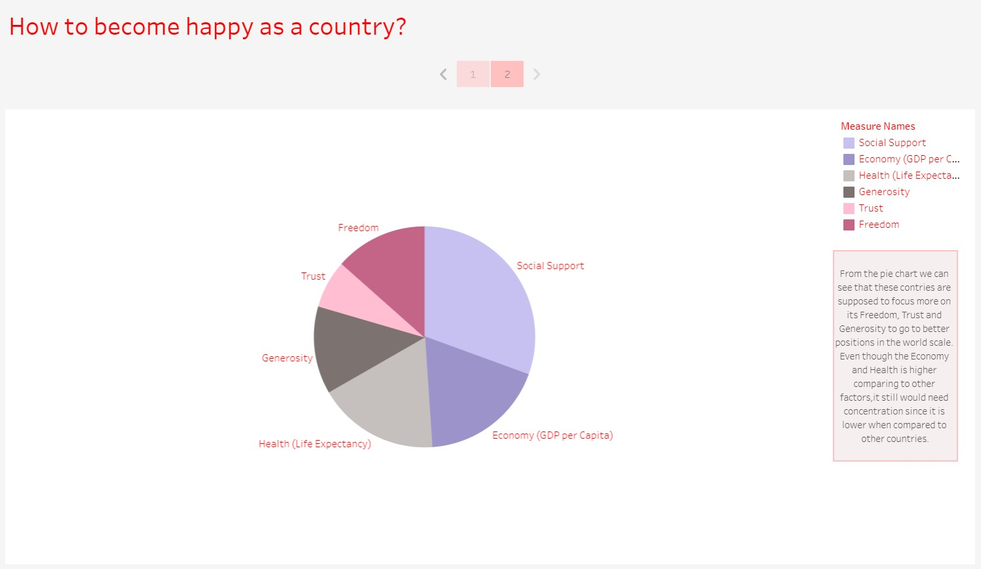

## 7.2 Python

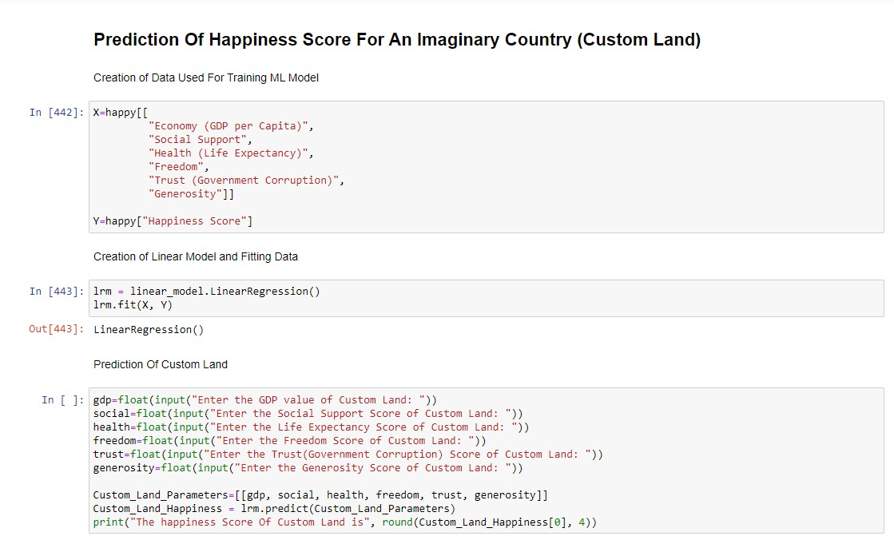



## 7.3 Web Page

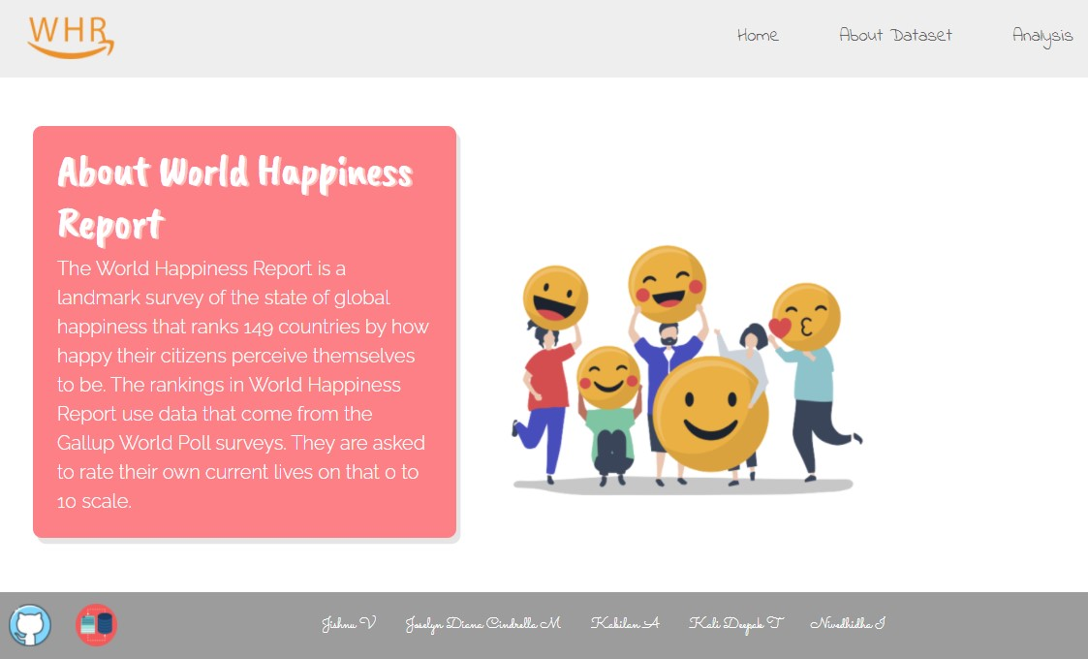

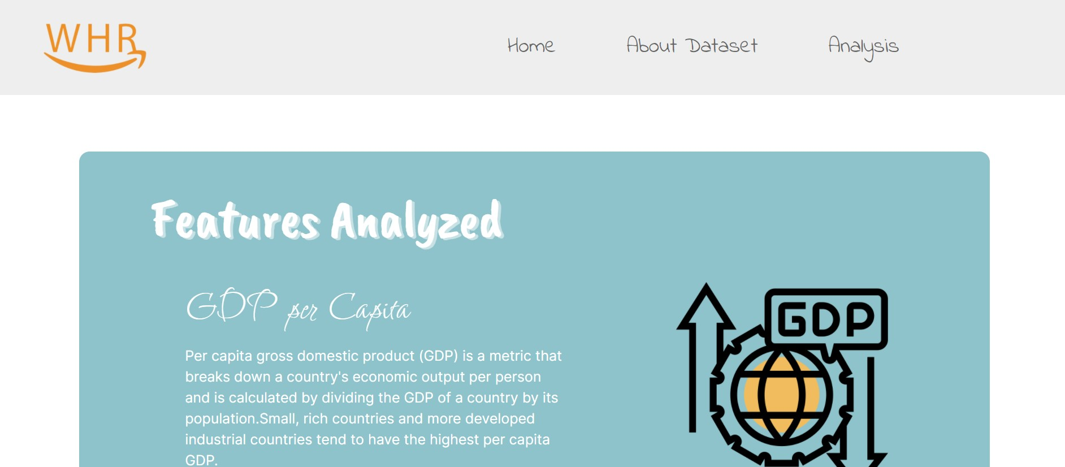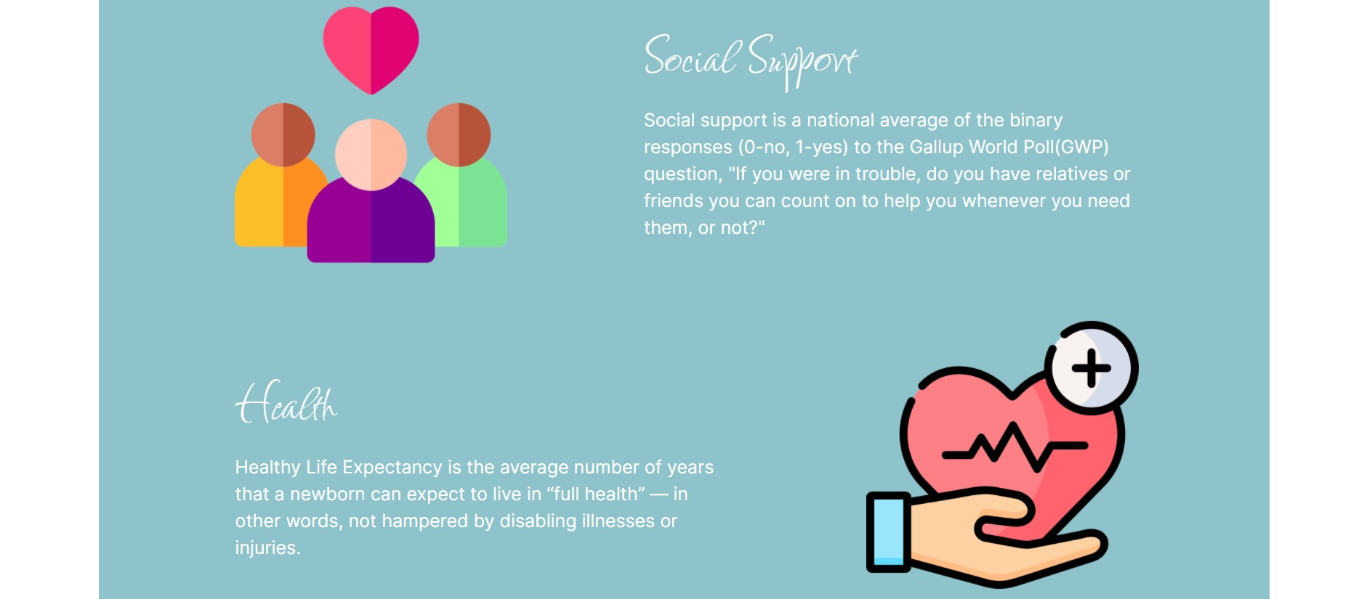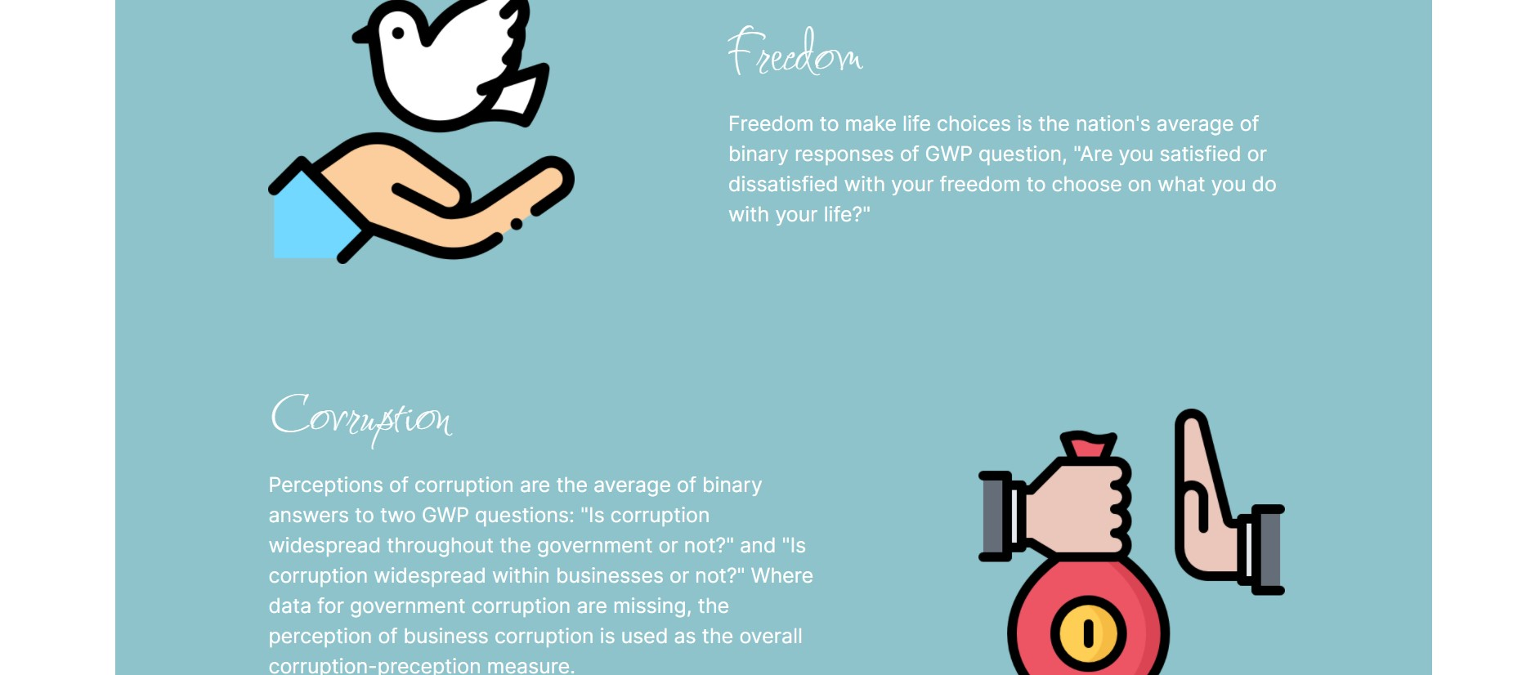

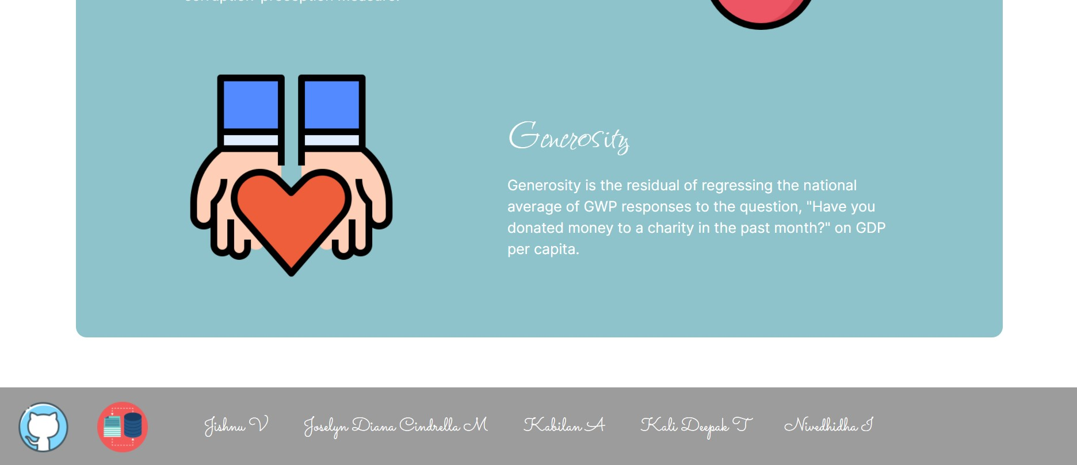

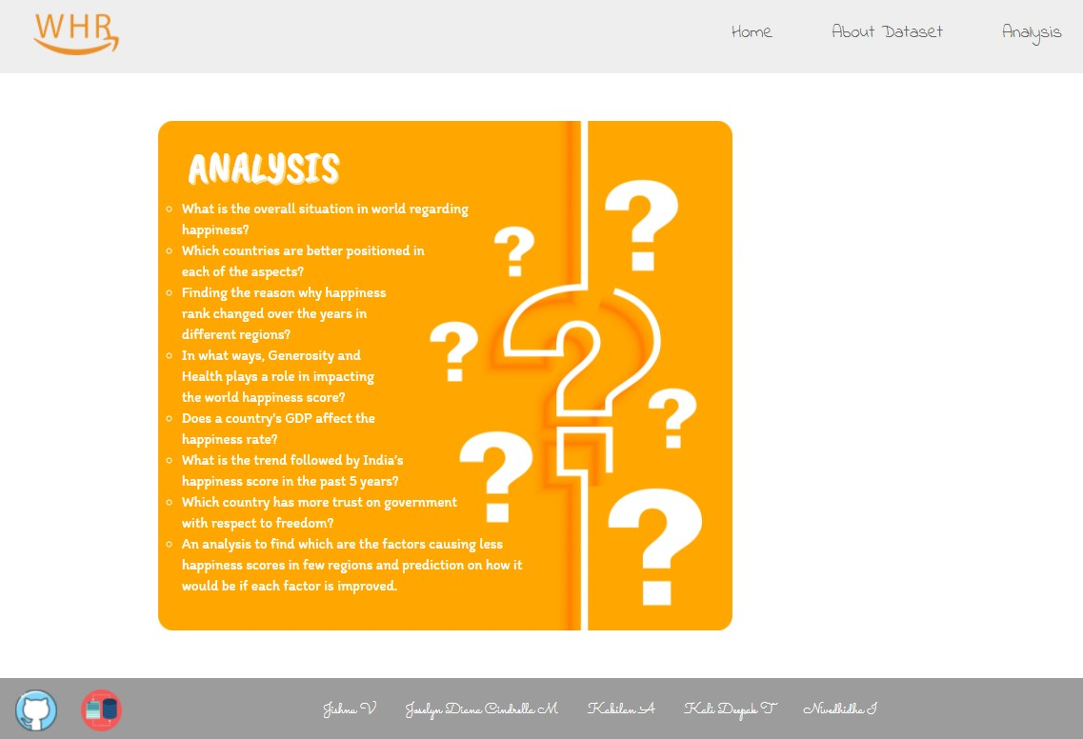

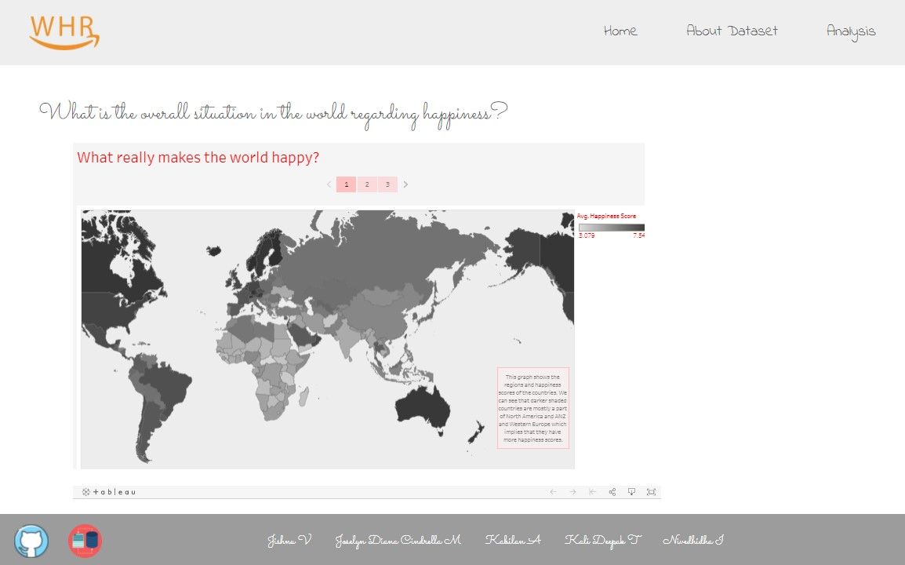

**8. SAMPLE CODE:**

**app.component.html**

<div class="container-fluid">

<div class="row header">

<div class="col-sm-4">

<a routerLink=""><img id="logo" src="../assets/logo.png" alt="Logo"></a>

</div>

<div class="col-sm-8">

<a class="link" routerLink="">Home</a>

<a class="link" routerLink="about">About Dataset</a>

<a class="link" routerLink="analysis">Analysis</a>

</div>

</div>

<div class="row">

<div class="col-sm-12">

<router-outlet></router-outlet>

</div>

</div>

<div class="row footer">

<div class="col-sm-2">

<a href="https://github.com/JoselynDianaCindrella21/World-Happiness-Report"><img class="icons" src="../assets/GitHub.jpg" alt="Github"></a>

<a href="https://www.kaggle.com/mathurinache/world-happiness-report?select=2020.csv"><img class="icons" src="../assets/kaggle.jpg" alt="Kaggle"></a>

</div>

<div class="col-sm-10">

<p>Jishnu V</p>

<p>Joselyn Diana Cindrella M</p>

<p>Kabilan A</p>

<p>Kali Deepak T</p>

<p>Nivedhidha I</p>

</div>

</div>

</div>

**app.component.css**

.header{ margin-bottom: 20px; background-color: rgba(128, 128, 128, 0.137); height: 135px;

}

#logo{ width: 150px; position: relative; left: 50px; top: 25px; } a{ text-decoration: none; font-family: 'Indie Flower', cursive; font-weight: 500; font-size: 30px; color: rgba(51, 51, 51, 0.726);

}

a:hover{ color: #000;

}

.link{ position: relative; top: 45px; left: 100px; margin-left: 100px;

}

div.row.footer{ padding-top: 0px; margin-top: 0px;

}

.footer{ margin-top: 20px; padding-top: 10px; color: white; background-color: #9C9C9C; font-family: 'Sacramento', cursive; font-size: 1.6rem;

}

.icons{ width: 70px; margin: 20px; }

p{

display: inline-block; margin: 36px 25px;

} **app-routing.module.ts**

import { NgModule } from '@angular/core'; import { RouterModule, Routes } from '@angular/router'; import { AboutComponent } from './about/about.component'; import { AnalysisComponent } from './analysis/analysis.component'; import { HomeComponent } from './home/home.component'; import { Q0Component } from './q0/q0.component';

import { Q1Component } from './q1/q1.component'; import { Q2Component } from './q2/q2.component'; import { Q3Component } from './q3/q3.component'; import { Q4Component } from './q4/q4.component'; import { Q5Component } from './q5/q5.component'; import { Q6Component } from './q6/q6.component'; import { Q7Component } from './q7/q7.component';

const routes: Routes = [

{path:"", component:HomeComponent},

{path:"about", component:AboutComponent},

{path:"analysis", component:AnalysisComponent},

{path:"q0", component:Q0Component},

{path:"q1", component:Q1Component},

{path:"q2", component:Q2Component},

{path:"q3", component:Q3Component},

{path:"q4", component:Q4Component},

{path:"q5", component:Q5Component},

{path:"q6", component:Q6Component},

{path:"q7", component:Q7Component}

];

@NgModule({

imports: [RouterModule.forRoot(routes)], exports: [RouterModule]

}) export class AppRoutingModule { }

**index.html**

<!doctype html>

<html lang="en">

<head>

<meta charset="utf-8">

<title>World Happiness Report</title>

<base href="/">

<meta name="viewport" content="width=device-width, initial-scale=1">

<link rel="icon" type="image/x-icon" href="favicon.ico">

<link rel="preconnect" href="https://fonts.googleapis.com">

<link rel="preconnect" href="https://fonts.gstatic.com" crossorigin>

<link rel="preconnect" href="https://fonts.googleapis.com">

<link rel="preconnect" href="https://fonts.gstatic.com" crossorigin>

<link href="https://fonts.googleapis.com/css2?family=Allura&family=Caveat+Brush&family=Fuggles&fa mily=Indie+Flower&family=Inter:wght@300&family=Itim&family=Raleway:wght@300&family=S acramento&display=swap" rel="stylesheet"> <app-root></app-root>

<link href="https://fonts.googleapis.com/css2?family=Tourney:wght@300&display=swap" rel="stylesheet">

<script src="https://public.tableau.com/javascripts/api/tableau-2.min.js"></script>

</body>

</html>

**9. TARGET AUDIENCE:**

* People who are interested in learning about World Happiness Report
* People who want to know about how the Report is made and based on what factors scores are given
* People who want to know about how different factors influence the happiness of the country
* People who are learning data analysis
* Data analysis enthusiasts

**10. FUTURE SCOPE:**

(Questions Which Can Be Addressed Later)

* What is the percentage of each factor, while taken for calculating the happiness score?
* What impact does Social Support Score have on the Happiness Rank?
* Is there any correlation between Social Support and Health?
* How Covid has brought a major change in people’s Health and did that affect the Happiness Score? (If we get the 2021 year dataset!)

1. **CONCLUSION:**

From the overall analysis, we can conclude that

The world happiness report depends on the average of scores, people give, based on opinions about how different factors make them happy. From the overall analysis of the World Happiness Report, we could come to a conclusion that the happiness scores vary based on different factors in different regions.

On the basis of the analysis that we made, we found that Economy(GDP per capita) and Social Support are the main factors on which happiness score depends.

1. **REFERENCES:**

* [**https://www.kaggle.com/mathurinache/world-happiness-report?selec t=2015.csv**](https://www.kaggle.com/mathurinache/world-happiness-report?select=2015.csv) **- for Collecting Dataset**
* [**https://en.wikipedia.org/wiki/World_Happiness_Report**](https://en.wikipedia.org/wiki/World_Happiness_Report) **- for**

**Understanding the Dataset**

* [**https://www.youtube.com/watch?v=aHaOIvR00So**](https://www.youtube.com/watch?v=aHaOIvR00So) **- for Learning Tableau**
* [**https://m.youtube.com/watch?v=CI2kX2EFhWc**](https://m.youtube.com/watch?v=CI2kX2EFhWc) **- for Learning React JS**
* [**https://plnkr.co/edit/ZSfSja?p=info&preview**](https://plnkr.co/edit/ZSfSja?p=info&preview) **- for Integration of Tableau into Website**
* [**https://www.datacamp.com/community/tutorials/git-push-pull**](https://www.datacamp.com/community/tutorials/git-push-pull) **- for Using GitHub Repository**
* [**https://youtu.be/lB4DTqMEumY**](https://youtu.be/lB4DTqMEumY) **- for Learning Hosting in AWS**